





SimSinter

Technical Manual

Version 2.0.1

March 2019

Copyright (c) 2012 - 2019

**Copyright Notice**

SimSinter was produced under the DOE Carbon Capture Simulation Initiative (CCSI), and is copyright (c) 2012 - 2019 by the software owners: Oak Ridge Institute for Science and Education (ORISE), TRIAD National Security, LLC., Lawrence Livermore National Security, LLC., The Regents of the University of California, through Lawrence Berkeley National Laboratory, Battelle Memorial Institute, Pacific Northwest Division through Pacific Northwest National Laboratory, Carnegie Mellon University, West Virginia University, Boston University, the Trustees of Princeton University, The University of Texas at Austin, URS Energy & Construction, Inc., et al.. All rights reserved.

NOTICE. This Software was developed under funding from the U.S. Department of Energy and the U.S. Government consequently retains certain rights. As such, the U.S. Government has been granted for itself and others acting on its behalf a paid-up, nonexclusive, irrevocable, worldwide license in the Software to reproduce, distribute copies to the public, prepare derivative works, and perform publicly and display publicly, and to permit other to do so.

**License Agreement**

SimSinter Copyright (c) 2012 - 2019, by the software owners: Oak Ridge Institute for Science and Education (ORISE), TRIAD National Security, LLC., Lawrence Livermore National Security, LLC., The Regents of the University of California, through Lawrence Berkeley National Laboratory, Battelle Memorial Institute, Pacific Northwest Division through Pacific Northwest National Laboratory, Carnegie Mellon University, West Virginia University, Boston University, the Trustees of Princeton University, The University of Texas at Austin, URS Energy & Construction, Inc., et al. All rights reserved.

Redistribution and use in source and binary forms, with or without modification, are permitted provided that the following conditions are met:

1. Redistributions of source code must retain the above copyright notice, this list of conditions and the following disclaimer.
2. Redistributions in binary form must reproduce the above copyright notice, this list of conditions and the following disclaimer in the documentation and/or other materials provided with the distribution.
3. Neither the name of the Carbon Capture Simulation Initiative, U.S. Dept. of Energy, the National Energy Technology Laboratory, Oak Ridge Institute for Science and Education (ORISE), TRIAD National Security, LLC., Lawrence Livermore National Security, LLC., the University of California, Lawrence Berkeley National Laboratory, Battelle Memorial Institute, Pacific Northwest National Laboratory, Carnegie Mellon University, West Virginia University, Boston University, the Trustees of Princeton University, the University of Texas at Austin, URS Energy & Construction, Inc., nor the names of its contributors may be used to endorse or promote products derived from this software without specific prior written permission.

THIS SOFTWARE IS PROVIDED BY THE COPYRIGHT HOLDERS AND CONTRIBUTORS "AS IS" AND ANY EXPRESS OR IMPLIED WARRANTIES, INCLUDING, BUT NOT LIMITED TO, THE IMPLIED WARRANTIES OF MERCHANTABILITY AND FITNESS FOR A PARTICULAR PURPOSE ARE DISCLAIMED. IN NO EVENT SHALL THE COPYRIGHT OWNER OR CONTRIBUTORS BE LIABLE FOR ANY DIRECT, INDIRECT, INCIDENTAL, SPECIAL, EXEMPLARY, OR CONSEQUENTIAL DAMAGES (INCLUDING, BUT NOT LIMITED TO, PROCUREMENT OF SUBSTITUTE GOODS OR SERVICES; LOSS OF USE, DATA, OR PROFITS; OR BUSINESS INTERRUPTION) HOWEVER CAUSED AND ON ANY THEORY OF LIABILITY, WHETHER IN CONTRACT, STRICT LIABILITY, OR TORT (INCLUDING NEGLIGENCE OR OTHERWISE) ARISING IN ANY WAY OUT OF THE USE OF THIS SOFTWARE, EVEN IF ADVISED OF THE POSSIBILITY OF SUCH DAMAGE.

You are under no obligation whatsoever to provide any bug fixes, patches, or upgrades to the features, functionality or performance of the source code ("Enhancements") to anyone; however, if you choose to make your Enhancements available either publicly, or directly to Lawrence Berkeley National Laboratory, without imposing a separate written license agreement for such Enhancements, then you hereby grant the following license: a non-exclusive, royalty-free perpetual license to install, use, modify, prepare derivative works, incorporate into other computer software, distribute, and sublicense such enhancements or derivative works thereof, in binary and source code form. This material was produced under the DOE Carbon Capture Simulation.

Table of Contents

SimSinter 1

1.0 Reporting Issues 1

2.0 Version Log 1

3.0 Introduction 1

3.1 Motivating Example 2

3.2 Features List 2

3.3 Overview: What a User Needs to Know About SimSinter and this Manual 3

4.0 Tutorial 4

4.1 Writing SimSinter Configuration Files 4

4.1.1 Creating a Steady State Aspen Custom Modeler Sinter Configuration File 4

4.1.2 Creating an Aspen Plus Sinter Configuration File 17

4.1.3 Creating a Microsoft Excel Sinter Configuration File 27

4.1.4 Creating a Dynamic ACM Simulation 36

4.2 Setting up Microsoft Excel → SimSinter 51

4.3 Using CSVConsoleSinter 55

4.4 Using ConsoleSinter 56

4.5 Using DefaultBuilder 56

5.0 Understanding SimSinter 57

5.1 Steady State Simulation 57

5.2 Dynamic Simulation 57

5.2.1 Overview 57

5.2.2 TimeSeries 57

5.2.3 Snapshot 58

5.2.4 Variables in Dynamic Simulations 58

6.0 SIMSinter Configuration File 60

6.1 Overview 60

6.2 Address Strings 61

6.3 Settings 63

6.4 Additional Variable Information 64

6.5 JSON Sinter Configuration Format 65

7.0 USAGE Information 71

7.1 Support 71

7.2 SinterConfigGUI Hot-Keys 71

7.2.1 Initial Page / Open File Page 71

7.2.2 Meta-Data Page 72

7.2.3 Variable Configuration Page 73

7.2.4 Vector Defaults Configuration Page 74

7.3 Unit of Measurement Conversion 74

7.4 Using the Included Command Line Tools 76

8.0 Debugging 76

8.1 How to Debug 76

8.2 Known Issues 77

8.3 Reporting Issues 88

List of Figures

Figure 1: Start menu, SinterConfigGUI. 4

Figure 2: SimSinter Configuration File Builder splash screen. 5

Figure 3: SinterConfigGUI Open Simulation window. 6

Figure 4: SimSinter Save Location. 7

Figure 5: Set Constraints on the Simulator Version 8

Figure 6: Additional Files may be attached via the Input Files list. 9

Figure 7: SinterConfigGUI Variable Configuration Page window. 10

Figure 8: Search In Progress Dialog Box 11

Figure 9: SinterConfigGUI Variable Configuration Page window, Flash.i_port.Connection(“Feed”).T variable selected. 11

Figure 10: SinterConfigGUI Variable Configuration Page window, Preview Variable frame. 12

Figure 11: SinterConfigGUI Variable Configuration Page window, Feed.T in Selected Input Variables. 13

Figure 12: SinterConfigGUI Variable Configuration Page window, Input Variable Name, Description, Min, and Max text boxes. 14

Figure 13: SinterConfigGUI Variable Configuration Page window, preview before making an output variable. 15

Figure 14: SinterConfigGUI Variable Configuration Page window, created output variable. 16

Figure 15: Start menu, SinterConfigGUI. 17

Figure 16: SimSinter Configuration File Builder splash screen. 17

Figure 17: SinterConfigGUI Open Simulation window. 18

Figure 18: SimSinter Save Location. 19

Figure 19: Set simulation version constraint 20

Figure 20: Additional Files may be attached via the Input Files list. 21

Figure 21: SinterConfigGUI Variable Configuration Page window. 22

Figure 22: SinterConfigGUI Variable Configuration Page window, Variable Tree nodes. 23

Figure 23: SinterConfigGUI Variable Configuration Page window, Preview Variable. 24

Figure 24: SinterConfigGUI Variable Configuration Page window, Input Variable Name, Description, Min, and Max text boxes. 25

Figure 25: SinterConfigGUI Variable Configuration Page window, Output Variable Name, Description, Min, and Max text boxes. 26

Figure 26: Start menu, SinterConfigGUI 27

Figure 27: SimSinter Configuration File Builder splash screen. 27

Figure 28: SinterConfigGUI Open Simulation window. 28

Figure 29: SimSinter Save Location. 29

Figure 30: Set Constraints on the Excel Version 30

Figure 31: Additional files can be attached 31

Figure 32: SinterConfigGUI Variable Configuration Page window. 32

Figure 33: SinterConfigGUI Variable Configuration Page window, Variable Tree. 33

Figure 34: SinterConfigGUI Variable Configuration Page window, Name, Description, Default, Min, and Max text boxes. 34

Figure 35: SinterConfigGUI Variable Configuration Page window, Output Variable. 35

Figure 36: Start menu, SinterConfigGUI. 36

Figure 37: SimSinter Configuration File Builder splash screen. 36

Figure 38: SinterConfigGUI Open Simulation window. 37

Figure 39: SimSinter Save Location. 38

Figure 40:Set Constraints on the Simulator Version 39

Figure 41: Begin adding additional files to the simulation 40

Figure 42: Attaching the tasksnap and snapshot files 41

Figure 43: The snapshot files have been attached. 42

Figure 44: SinterConfigGUI Variable Configuration Page for Dynamic ACM. 43

Figure 45: ACM Tools → SnapShot, Snapshot Management window. 44

Figure 46: SnapShot setting default set. 45

Figure 47: Variable Search, Search In Progress window. 45

Figure 48: Selecting a Steady State variable. 46

Figure 49: Make a Dynamic variable. 47

Figure 50: Making a Dynamic output variable. 48

Figure 51: Making a Steady State output variable. 49

Figure 52: Vector Default Initialization window. 49

Figure 53: A default TimeSeries. 50

Figure 54: Microsoft Excel, Flash_Example_ACS.xlsm. 54

Figure 55: Microsoft Excel, Flash_Example_ACS.xlsm results. 54

Figure 56: Windows Task Manager, Processes tab, AspenModeler.exe. 77

Figure 57: Aspen Sinter Configuration UI ERROR. 79

Figure 58: Excel Error Received When Using SimSinter 80

Figure 59: References window, MISSING:SimSinter library. 81

Figure 60: Navigating to the SimSinter library from C:. 82

Figure 61: Navigating to the SimSinter library from Program Files. 82

Figure 62: Navigating to the SimSinter library directory. 83

Figure 63: Selecting the Sinter.tlb library. 83

Figure 64: SimSinter library is selected. 84

Figure 65: Excel’s Visual Basic window. 85

Figure 66: References window. 86

Figure 67: Cleared “OLE Automation” check box. 86

Figure 68: Selected “OLE Automation” check box. 87

To obtain support for the products within this package, please send an e-mail to   
[ccsi-support@acceleratecarboncapture.org](mailto:ccsi-support@acceleratecarboncapture.org).

SimSinter

1. Reporting Issues

To report an issue, please send an e-mail to [ccsi-support@acceleratecarboncapture.org](mailto:ccsi-support@acceleratecarboncapture.org).

1. Version Log

| Product | Version Number | Release Date | Description |
| --- | --- | --- | --- |
| SimSinter | 2.0.1 | 08/15/2019 | License update (no functional changes) |
| SimSinter | 2.0.0 | 03/31/2018 | Initial Open Source release |
| SimSinter | 2016.04.00 | 04/20/2016 | 2016 May Release-  Added DMF integration and additional meta-data to Sinter Config Files for use by the DMF. |
| SimSinter | 2015.10.00 | 11/20/2015 | 2015 November IAB Release –  Added PSE gPROMS support. Please see the SimSinter gPROMS Technical Manual. |
| SimSinter | 2015.6.00 | 06/30/2015 | 2015 June incremental Release – Added Dynamic ACM support. |
| SimSinter | 2014.10.0 | 10/31/2014 | 2014 October IAB Release – Added FOQUS Integration. |

1. Introduction

SimSinter is a standard interface library for driving single-process Windows®-based simulation software. SimSinter supports:

* Aspen Plus® 7.3.2 or newer
* Aspen Custom Modeler® (ACM) 7.3.2 or newer,
* PSE gPROMS 4.0.0 or newer,
* Microsoft® Excel® 2010 (14.0) or newer

When called, SimSinter can open the simulator, initialize the simulation, set variables in the simulation, run the simulation, and get the resulting output variables from the simulation. SimSinter is an integral part of the Turbine Gateway and every other Carbon Capture Simulation Initiative (CCSI) tool that runs process simulations.

* 1. Motivating Example

Aspen Plus runs a single process simulation by itself just fine, so why is SimSinter necessary? SimSinter is most useful for running sets of simulations designed by some other software.

A common use case is parameter studies for uncertainly quantification (UQ). A new carbon capture process simulation was designed where the reaction parameters for carbon capture and release were determined experimentally. Those experiments provided bounds for the reaction parameters, but how the process would perform with in that range still had to be determined.

A set of 40,000 runs was designed in the PSUADE Uncertainty Quantification tool. Using TurbineClient/PSUADESinter the 40,000 jobs were sent to the Gateway. The Gateway launched 100 ACM instances via SimSinter and ran all 40,000 jobs over three days. The results of the simulation were retreived from the Gateway with FOQUS. Those results were loaded back into PSUADE. With PSUADE the effectiveness of the simulation and under what conditions the simulation would have problems were analyzed.

* 1. Features List

SimSinter can interface to the following simulators:

1. Aspen Plus (v7.3.2 or newer)
2. ACM (Steady State, Dynamic, and Optimization run modes) v7.3.2 or newer
3. PSE gPROMS (v4.0 or newer)
4. Microsoft Excel (2010 or newer)

SimSinter can be called from the following interfaces:

1. The Turbine Gateway (or a standalone Gateway). The Gateway can be called either from the Framework for Optimization and Quantification of Uncertainty and Sensitivity (FOQUS) or TurbineClient. TurbineClient can take JSON, PSUADE, or CSV (Comma Separated Values, a common spreadsheet format) files.
2. Microsoft Excel. The SimSinter installation includes a spreadsheet that can be used with any Sinter configuration file to perform a single run or series of runs on the user’s workstation.
3. The standalone tools included with the SimSinter installation such as ConsoleSinter, which can run a single run or series of runs on the user’s workstation.

SimSinter also installs the following helper tools:

* SinterConfigGUI: Used to generate JSON format configuration files by enabling the user to interface with Aspen or Excel.
* ConsoleSinter: Takes JSON format inputs to perform a run or series of runs locally.
* CSVConsoleSinter: Takes .csv to perform a series of runs locally.
* DefaultBuilder: Generates a JSON format file of defaults, pulled from the current values of the inputs in the simulation file. (This file is useful for generating some example inputs for running ConsoleSinter.)
  1. Overview: What a User Needs to Know About SimSinter and this Manual

If SimSinter is to be used with gPROMS, another manual is required. gPROMS is so different from the Aspen and Excel simulators, that it could not be well integrated with this document. Please see the SimSinter gPROMS Technical Manual.

SimSinter itself must be run on a machine that has the simulator and all of the necessary licenses installed. For example, SimSinter could run Aspen Plus simulations on a desktop computer that has Aspen Plus installed and the necessary Aspen Plus licenses. This includes configuring simulations with the SinterConfigGUI. SinterConfigGUI interfaces with the simulator to interrogate the simulation. So SimSinter and the simulator must exist on the same machine.

However, a user that does not have a simulator license may still use SimSinter if they have access to a remote computer that has the simulator installed, and also has the Turbine Science Gateway installed. In this case, the user can send their simulations to the Gateway, and the Gateway computer runs SimSinter and the simulator. (Or, it may, farm the actually running of SimSinter and the simulator off to another machine that has the licenses.)

There are two ways a user can run SimSinter:

1. Remotely by the Turbine Gateway or by a standalone Gateway installation.
2. Locally (on the same machine the user is using) by Microsoft Excel or by one of the tools included with the SimSinter installation.

For the remainder of this manual it is assumed that the user is running SimSinter locally. Special cases for the Gateway are documented as needed.

To drive a simulation SimSinter requires at least two files, which should be in the same directory.

1. The simulation file to run SimSinter. This file is simulator specific. The file defines the simulation for the simulator. For example, for Aspen Plus this file can be a .bkp or .apw file.
2. The Sinter configuration file is a JSON file that gives meta-data about the simulation. Including all the input and output variables the simulation writer thinks the user might find useful, including name, type, defaults, units, and possible minimum and maximum values.

For some simulations additional files are required, for example, some ACM simulations have a snapshot file, or additional simulator functionality contained in a DLL. The files should be listed in the SimSinter configuration file so that Turbine and the Data Management Framework are aware of them, and can place them in the correct directories for running the simulation.

SimSinter produces inputs and outputs in a simple JSON format. JSON is easy for programs to parse and manipulate, but it is not easy to read, nor is it used by most scientific tools. Furthermore, even though SimSinter only writes the output variables requested in the Sinter configuration file, the user is usually only interested in a small subset of those variables.

Therefore, aside from the Excel SimSinter Interface, there are tools for converting the outputs to two other useful formats: PSUADE format and CSV format. A user can perform sets of runs in CSV format directly with the included tool CSVConsoleSinter. Otherwise, refer to the documentation for TurbineClient, which includes tools for converting to and from PSUADE and CSV format, as well as doing Gateway runs with those formats.

1. Tutorial

This section consists of tutorials for simulation writers and users to perform the most common tasks with SimSinter. These tutorials focus on running SimSinter locally, as there are separate tutorials for running Aspen with the Gateway available in the FOQUS User Manual.

This manual also does not cover running gPROMS with SimSinter. Please see the SimSinter gPROMS Technical Manual.

* 1. Writing SimSinter Configuration Files

Description

The SimSinter configuration files are intended to be written by a user with an intimate understanding of the simulation that the files are run on, usually the simulation writer. Any simulation has a gargantuan list of possible input and output variables. The primary job of the configuration file is to pare the list down to just the variables of interest.

The JSON format is difficult to write. A Graphical User Interface (GUI) has been developed that makes this task much simpler.

The following sections contain demonstrations on writing files for three of the supported simulators, Aspen Plus, ACM, and Microsoft Excel. For a tutorial on using SimSinter with gPROMS, see the SimSinter gPROMS Technical Manual. Before reading these sections, read Section 6.1 Overview, which provides and overview of the components of a Sinter configuration file. This section assumes the user has read Section 5.1 Steady State Simulation.

* + 1. Creating a Steady State Aspen Custom Modeler Sinter Configuration File

1. Open the “SinterConfigGUI” from the “Start” menu, as shown in Figure 1.

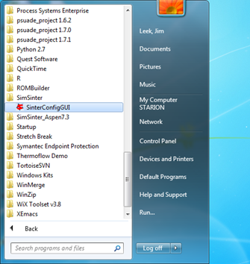

Figure 1: Start menu, SinterConfigGUI.

1. Initially the SimSinter Configuration File Builder splash screen displays, as shown in Figure 2. Either click the “splash screen” to proceed, or wait 10 seconds for the screen to close automatically.

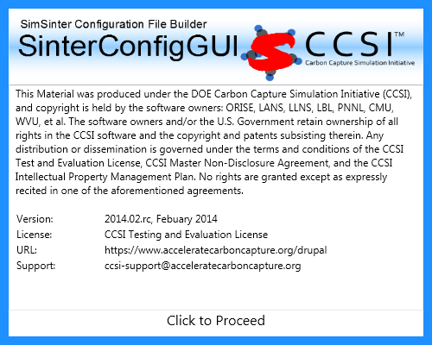

Figure 2: SimSinter Configuration File Builder splash screen.

1. The SinterConfigGUI Open Simulation window displays as shown in Figure 3. Click “Browse” to select the file to open, or type the filename into the text box and click “Open File and Configure Variables” to open the file. The user can either open a fresh ACM simulation (.acmf file) or an existing Sinter configuration file. In these instructions, the ACM test included in the SimSinter installation at C:\SimSinterFiles\ACM_Install_Test\Flash_Example.acmf is opened.

After clicking “Open File and Configure Variables,” it may take a few minutes for the SinterConfigGUI to proceed. The SinterConfigGUI must open the simulator, taking as long as the simulator normally takes to open. For Aspen products that use a networked license server, this may take a few minutes. During that time the SinterConfigGUI remains on the Open File Page and the “Attempting to Open Aspen” message appears at the bottom of the window.

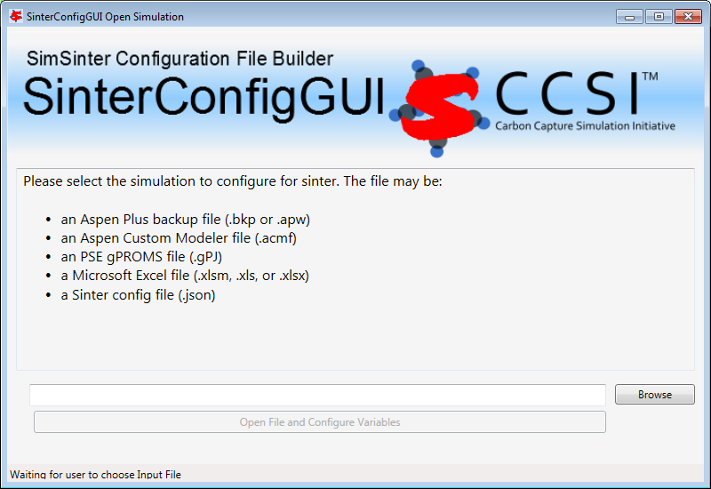

Figure 3: SinterConfigGUI Open Simulation window.

1. The SinterConfigGUI Simulation Meta-Data window displays as shown in Figure 4, and ACM has started up in the background. This is so the user can observe things about the simulation in question as they work on the configuration file. The first and most important piece of meta-data is the “SimSinter Save Location” at the top of the window. This is where the Sinter configuration file is saved. The system suggests a file location and name. SimSinter automatically saves changes to this file. If the built in test files are being used for this tutorial, it is recommend that the name of the save file be changed before proceeding to avoid overwriting the configuration that came with the installation.

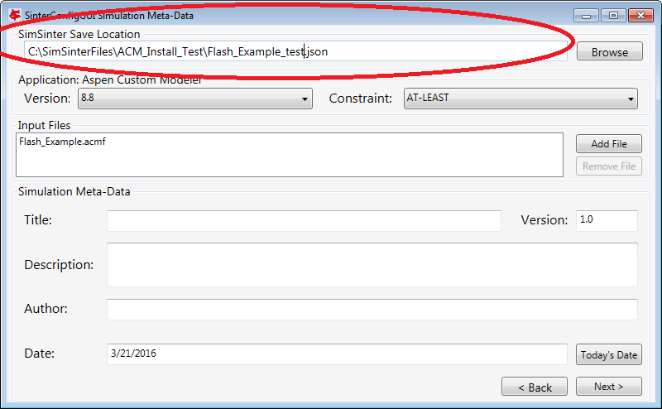

Figure 4: SimSinter Save Location.

1. SimSinter allows the user to restrict the simulator versions that maybe used with the simulation. By default SimSinter will set the restriction to be at least the newest version of the simulator on the current machine. However, the user may select any version of the simulator supported by SimSinter, and may constrain it in any of the following ways:  
   ANY: SimSinter will attempt to launch the newest version of the simulator available, and will not throw an error, no matter which version is actually launched.  
   AT-LEAST: SimSinter will launch the newest version of the simulator available, but it will throw an error if the version launched is older than the recommended version.  
   REQUIRED: SimSinter will attempt to launch the recommended version, if it does not exist, SimSinter will throw an error and will not run the simulation.  
   RECOMMENDED: SimSinter will attempt to launch the recommended version, if it can’t be found, the newest version available will be launched. If that version is older than the recommended version, SimSinter will throw an error.  
     
   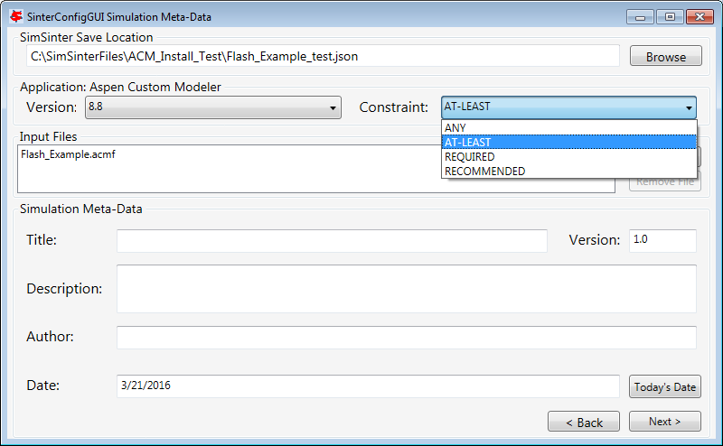

Figure 5: Set Constraints on the Simulator Version

1. Some simulations have additional files they require to run. For example, dynamic simulations often have a snapshot.snp file so that the simulation can be restarted from a known state.  
   This simulation does not have any additional files, so a full tutorial will not be given here. For more information see the Dynamic ACM simulation section 4.1.4 . But these additional files may be attached to the simulation via the Input Files section. The simulation file itself is always included in the Input Files, and cannot be removed.  
   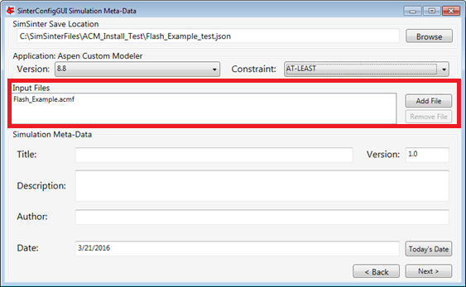

Figure 6: Additional Files may be attached via the Input Files list.

1. The SinterConfigGUI Variable Configuration Page window displays as shown the Figure. The ACM Setting variables are already included in the Selected Input Variables. For this simulation, “homotopy” is off by default; therefore, it is set to “0.” There are three other settings, “TimeSeries,” “Snapshot,” and “RunMode.” Leave “RunMode” set to “Steady State.” “Snapshot” and “TimeSeries” are only for Dynamic simulations, so leave them alone as well.

On the left of the window is a “Variable Search” box. This search is exactly the same as “Variable Find” on the “Tools” menu in ACM. Refer to the ACM documentation for details on search patterns.

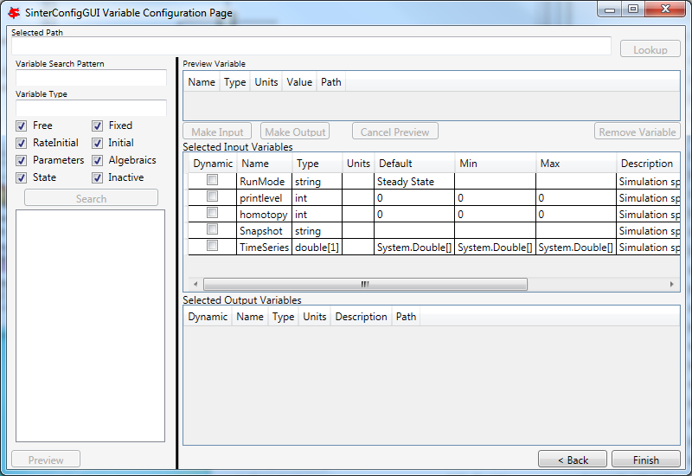

Figure 7: SinterConfigGUI Variable Configuration Page window.

1. Enter search for everything in the Flash block (“Flash.~”). The Search In Progress dialog box may appear, as shown below.

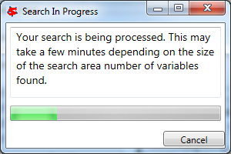

Figure 8: Search In Progress Dialog Box

1. Select the “Flash.i_port.Connection(“Feed”).T” scalar variable.

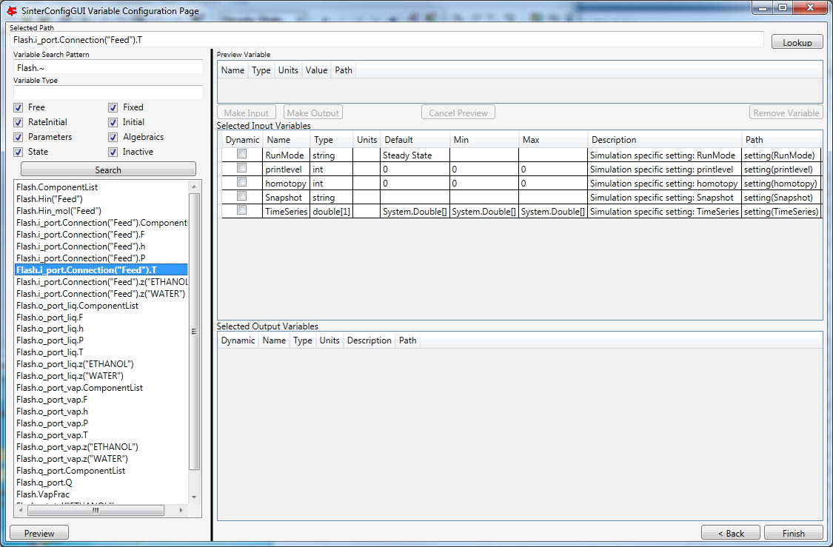

Figure 9: SinterConfigGUI Variable Configuration Page window, Flash.i_port.Connection(“Feed”).T variable selected.

1. Double-click the variable, press “Enter,” or click “Preview” or “Lookup” to display the variable in the Preview Variable frame to confirm the correct variable is selected.

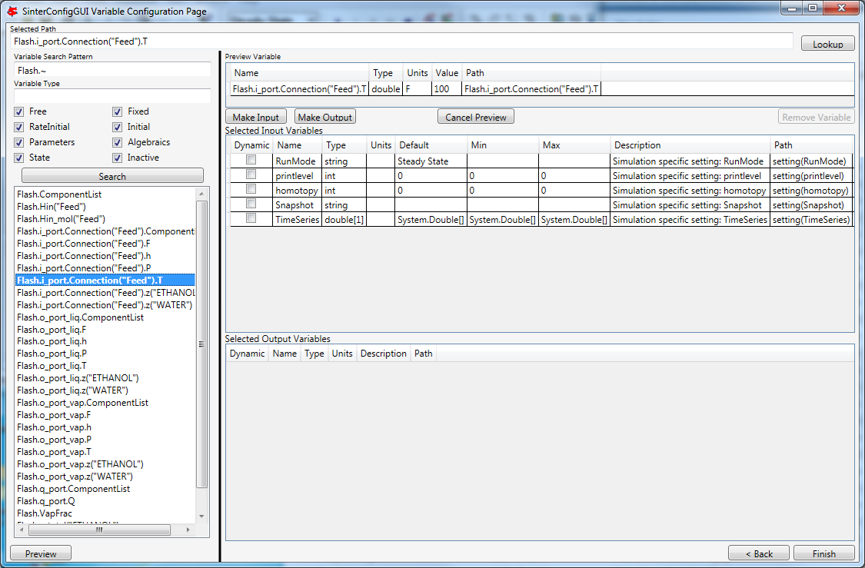

Figure 10: SinterConfigGUI Variable Configuration Page window, Preview Variable frame.

1. Confirm visually that it is the intended variable. Click “Make Input” and the variable displays in the “Selected Input Variables” section as shown in Figure 11. Leave the “Dynamic” check box on the far left cleared. Dynamic variables are only for use with Dynamic simulations, and the RunMode is set to “Steady State.”

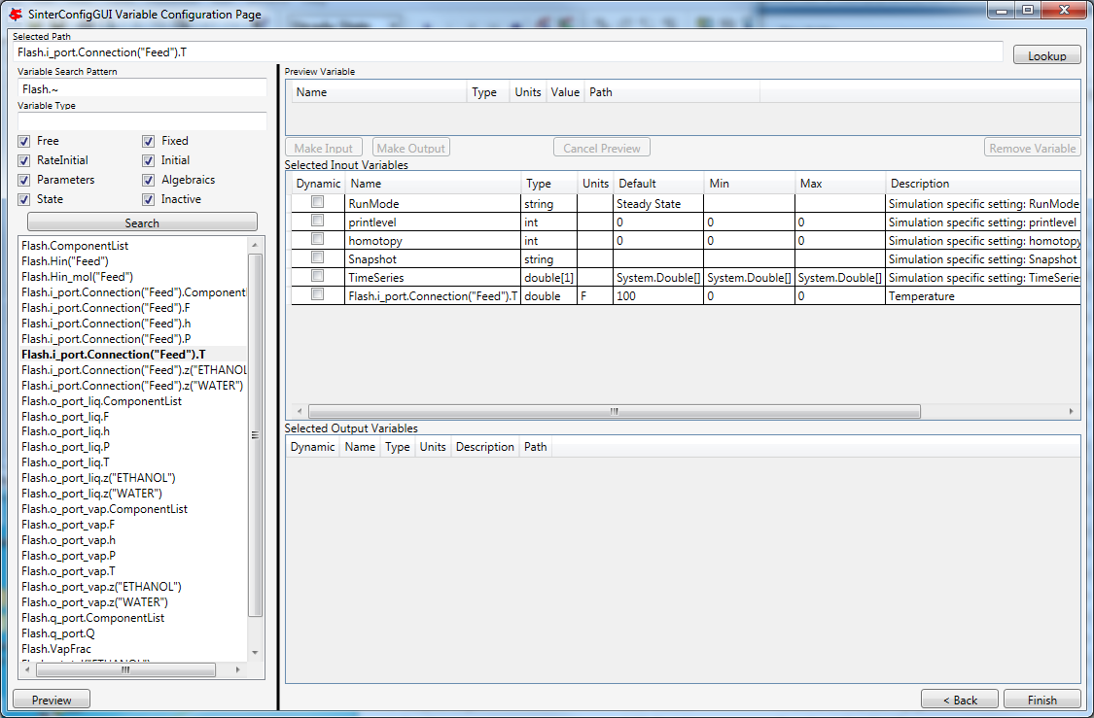

Figure 11: SinterConfigGUI Variable Configuration Page window,  
Feed.T in Selected Input Variables.

1. To rename the Selected Input Variable name (e.g., Flash.i_port.Connection(“Feed”).T) to a more descriptive name, click the “Name” text box and then enter a name. A user can also enter a “Description” and the “Min” and “Max” ranges, as shown in Figure 12.

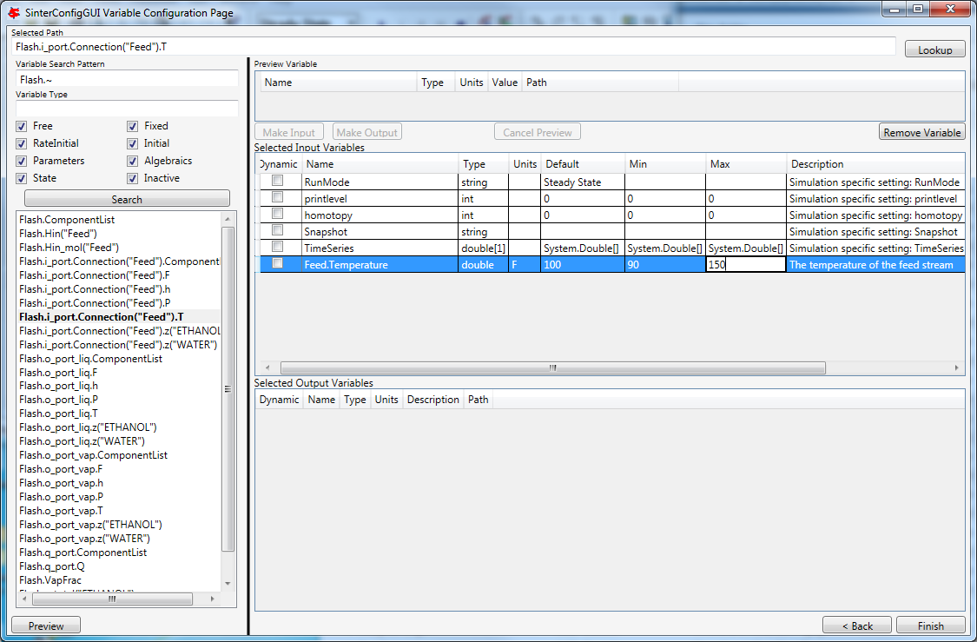

Figure 12: SinterConfigGUI Variable Configuration Page window,  
Input Variable Name, Description, Min, and Max text boxes.

1. To add an output variable (for example, the fraction of the output vapor stream that is water), scroll down to find “Flash.o_port_var.z(“WATER”).” Select it and then preview it as described in Step 10.

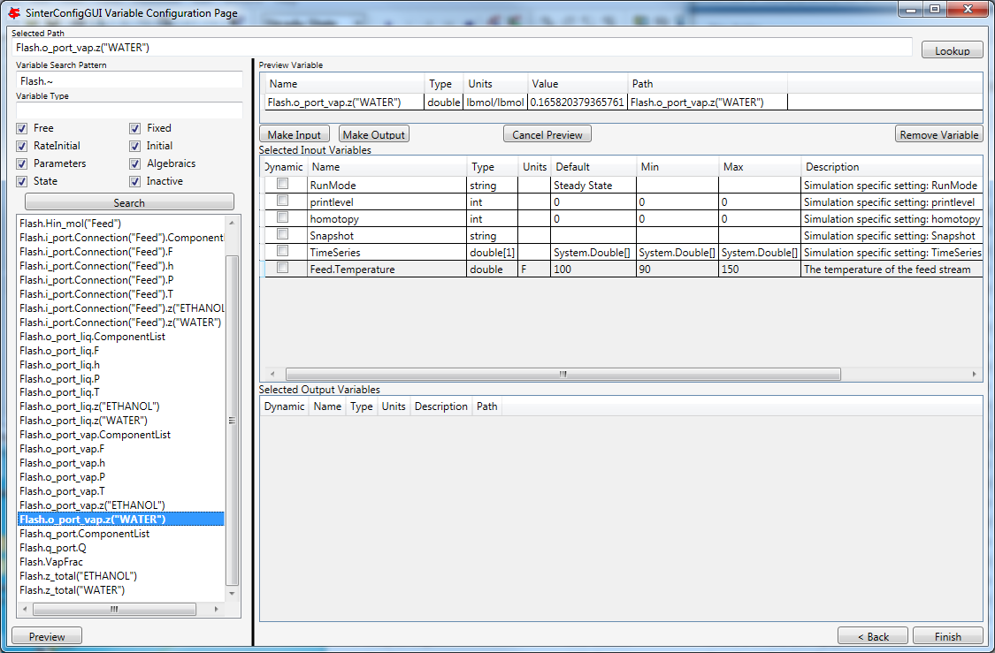

Figure 13: SinterConfigGUI Variable Configuration Page window,  
preview before making an output variable.

1. Click “Make Output.” This variable has a unit “lbmol/libmol” as shown in Figure 14.

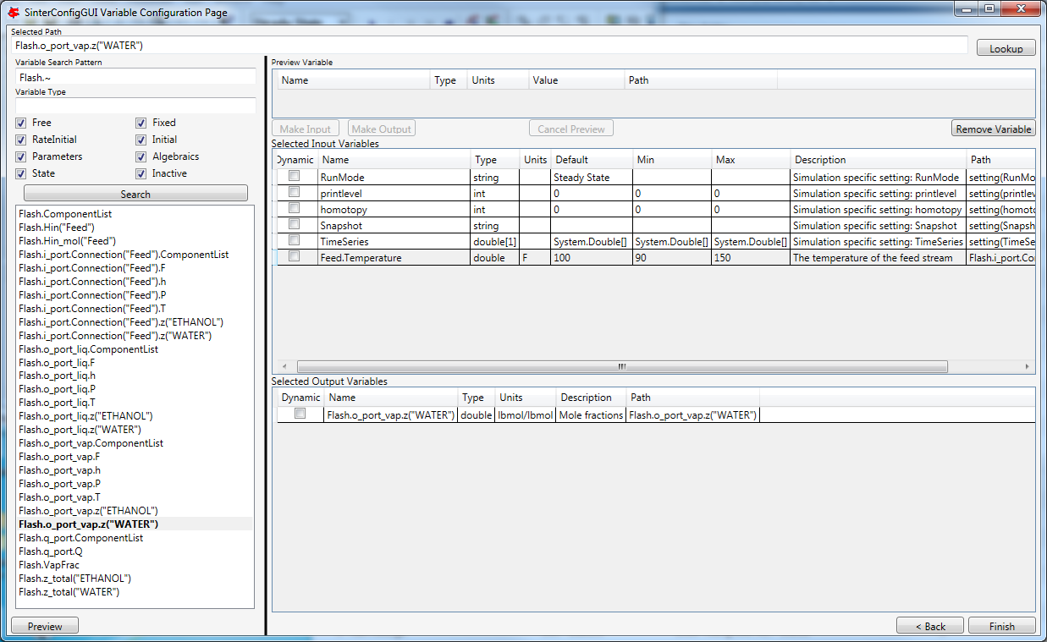

Figure 14: SinterConfigGUI Variable Configuration Page window, created output variable.

1. The simulation is now set up. To save the configuration file, click “Finish” or press “CTRL+S.” The file is saved to the location that was set on the Meta-Data window. A user can save a copy under a different name, by navigating back to the Meta-Data window using “Back,” and then changing the name. This creates a second version of the file.

A user also needs to close the ACM simulator, which remains open after SinterConfigGUI finishes.

* + 1. Creating an Aspen Plus Sinter Configuration File

1. Open the “SinterConfigGUI” from the “Start” menu, as shown in Figure 13.

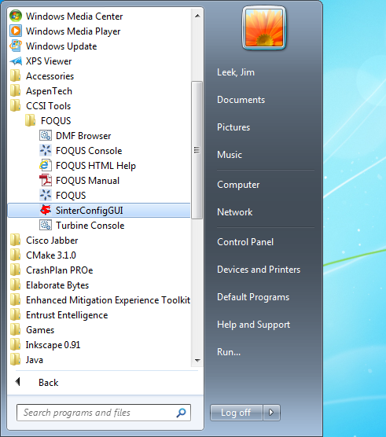

Figure 15: Start menu, SinterConfigGUI.

1. Initially the SimSinter Configuration File Builder splash screen displays, as shown in Figure 16. Either click the “splash screen” to proceed, or wait 10 seconds for the screen to close automatically.



Figure 16: SimSinter Configuration File Builder splash screen.

1. The SinterConfigGUI Open Simulation window displays as shown in Figure 17. Click “Browse” to select the file to open, or type in a filename and click “Open File and Configure Variables” to open the file. The user can either open a fresh Aspen Plus simulation (.bkp or .apw file) or an existing Sinter configuration file (.json). In these instructions a fresh copy of the included Aspen Plus flash column test is opened, it can be found at C:\SimSinterFiles\Aspen_Plus_Install_Test\Flash_Example.bkp.

After clicking “Open File and Configure Variables,” it may take a few minutes for the SinterConfigGUI to proceed. The SinterConfigGUI must open the simulator, taking as long as the simulator normally takes to open. For Aspen products that use a networked license server, this may take a few minutes. During that time the SinterConfigGUI remains on the Open File Page and the “Attempting to Open Aspen” message appears at the bottom of the window.



Figure 17: SinterConfigGUI Open Simulation window.

1. The SinterConfigGUI Simulation Meta-Data window displays as shown in the Figure, and Aspen Plus started up in the background. This is so the user can observe things about the simulation in question as they work on the configuration file.

The first and most important piece of meta-data is the “SimSinter Save Location” at the top of the window. This is where the Sinter configuration file is saved. The system suggests a file location and name. The user should confirm this is the intended location of the files to not accidently overwrite other files.

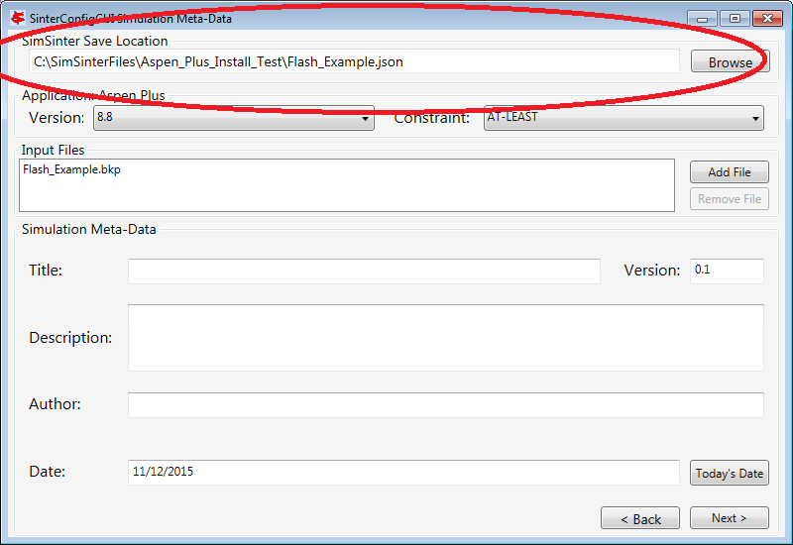

Figure 18: SimSinter Save Location.

1. SimSinter allows the user to restrict the simulator versions that maybe used with the simulation. By default SimSinter will set the restriction to be: at least the newest version of the simulator on the current machine. However, the user may select any version of the simulator supported by SimSinter, and may constrain it in any of the following ways:  
   ANY: SimSinter will attempt to launch the newest version of the simulator available, and will not throw an error, no matter which version is actually launched.  
   AT-LEAST: SimSinter will launch the newest version of the simulator available, but it will throw an error if the version launched is older than the recommended version.  
   REQUIRED: SimSinter will attempt to launch the recommended version, if it does not exist, SimSinter will throw an error and will not run the simulation.  
   RECOMMENDED: SimSinter will attempt to launch the recommended version, if it can’t be found, the newest version available will be launched. The that version is older than the recommended version, SimSinter will throw an error.  
     
   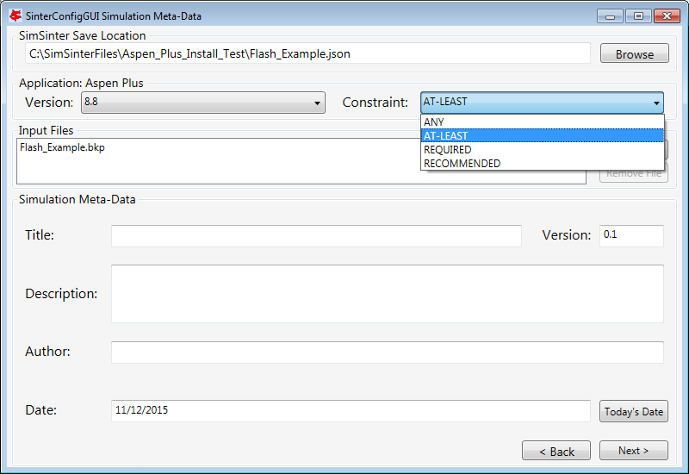

Figure 19: Set simulation version constraint

1. Some simulations have additional files they require to run. For example, dynamic simulations often have a snapshot.snp file so that the simulation can be restarted from a known state.  
   This simulation does not have any additional files, so a full tutorial will not be given here. For more information see the Dynamic ACM simulation section 4.1.4 . But these additional files may be attached to the simulation via the Input Files section. The simulation file itself is always included in the Input Files, and cannot be removed.  
     
   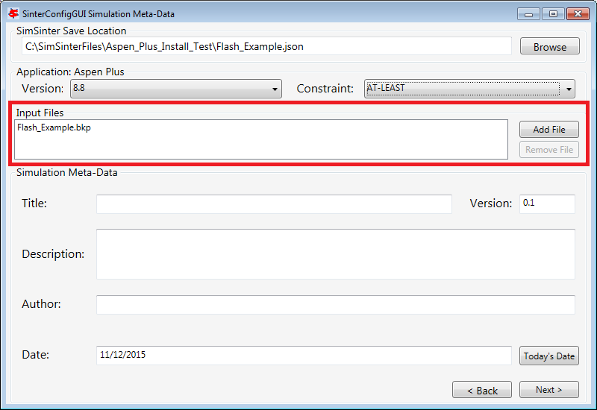

Figure 20: Additional Files may be attached via the Input Files list.

1. Enter the remaining fields to provide the meta-data to describe the simulation that was just opened and then click “Next” (or save, “CTRL+S”).
2. The SinterConfigGUI Variable Configuration Page window displays as shown the Figure below. Aspen Plus has no settings; therefore, there are no settings variables in the “Selected Input Variables” section.

Unlike ACM, Aspen Plus has the variable tree on the left side, so the user can explore the tree as they do in Aspen Plus Tools → Variable Explorer.

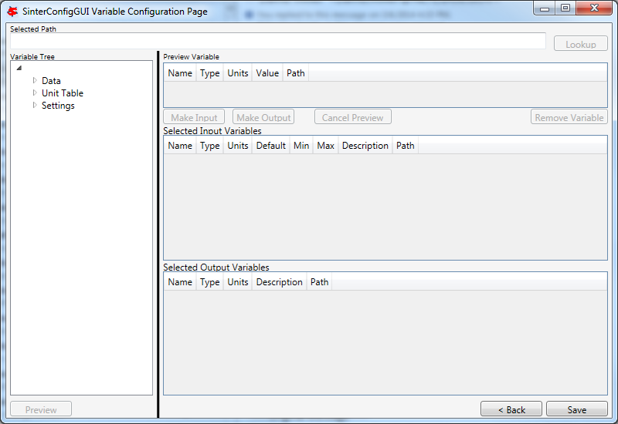

Figure 21: SinterConfigGUI Variable Configuration Page window.

A user can expand the Variable Tree nodes for searching as shown in Figure 22.

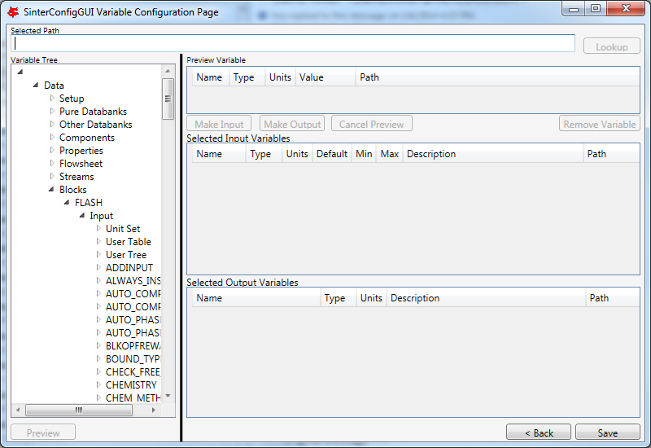

Figure 22: SinterConfigGUI Variable Configuration Page window, Variable Tree nodes.

1. Type the node address in the “Selected Path” text box and then press “Enter” or click “Lookup” or “Preview.” This automatically expands the tree and selects the entered variable in the Variable Tree, as shown the Figure.

The “Selected Path” text box is useful for Copy and Paste from Aspen Plus’ Variable Explorer.

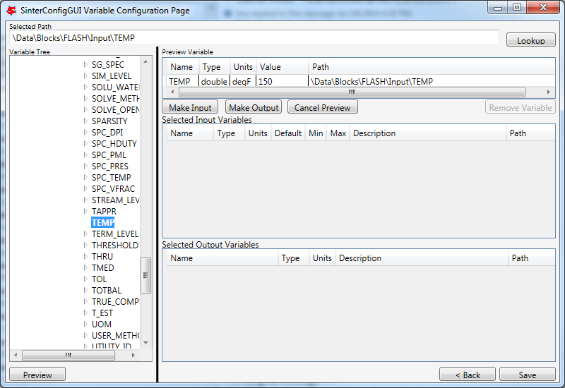

Figure 23: SinterConfigGUI Variable Configuration Page window, Preview Variable.

1. To make the temperature of the Flash chamber an input variable, click “Make Input.” Optionally, a user can also rename the Variable and “Description,” and enter the “Min” and “Max” fields by clicking the appropriate text box and then entering the applicable information, as shown in the Figure.

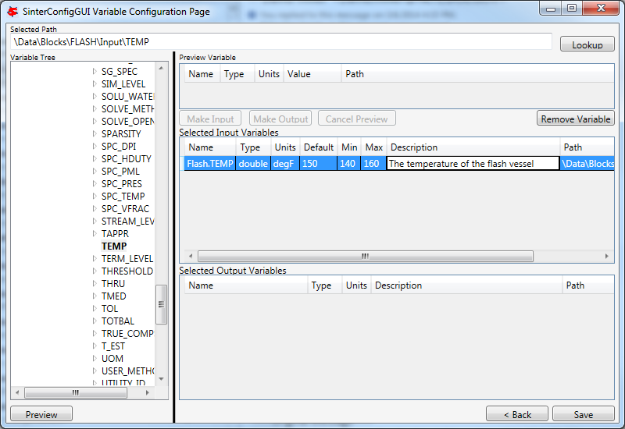

Figure 24: SinterConfigGUI Variable Configuration Page window,  
Input Variable Name, Description, Min, and Max text boxes.

1. Select an output variable, click “Preview,” and then click “Make Output.” Optionally, rename the Variable and the “Description,” and enter the “Min” and “Max” fields by clicking the appropriate text box and then entering the applicable information, as shown in the Figure.

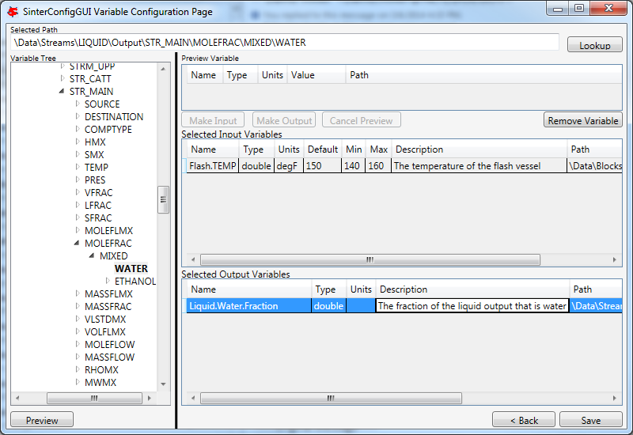

Figure 25: SinterConfigGUI Variable Configuration Page window,  
Output Variable Name, Description, Min, and Max text boxes.

1. The simulation is now set up. To save the configuration file, click “Finish” or press “CTRL+S.” The file is saved to the location that was set on the Meta-Data window. A user can save a copy under a different name, by navigating back to the Meta-Data window using “Back,” and then changing the name. This creates a second version of the file.
   * 1. Creating a Microsoft Excel Sinter Configuration File
2. Open the “SinterConfigGUI” from the “Start” menu, as shown in Figure 26.

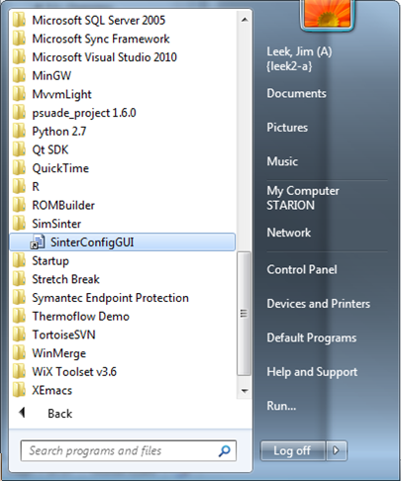

Figure 26: Start menu, SinterConfigGUI

1. Initially the SimSinter Configuration File Builder splash screen displays, as shown in Figure 27. Either click the “splash screen” to proceed, or wait 10 seconds for the screen to close automatically.



Figure 27: SimSinter Configuration File Builder splash screen.

1. The SinterConfigGUI Open Simulation window displays as shown in Figure 28. Click “Browse” to select the file to open and then click “Open File and Configure Variables” to open the file. The user can either open a fresh Microsoft Excel simulation (.xlsm, .xls, or .xlsx file) or an existing Sinter configuration file. In these instructions, a fresh copy of the BMI test is opened. It can be found at: C:\SimSinterFiles\Excel_Install_Test\exceltest.xlsm.



Figure 28: SinterConfigGUI Open Simulation window.

Microsoft Excel started up in the background. This is so the user can observe things about the simulation in question as they work on the configuration file.

1. The SinterConfigGUI Simulation Meta-Data window displays as shown in Figure 29. The first and most important piece of meta-data is the “SimSinter Save Location” at the top of the window. This is where the Sinter configuration file is saved. The system suggests a file location and name. The user should confirm that this is the intended location of the files to not accidently overwrite other files.

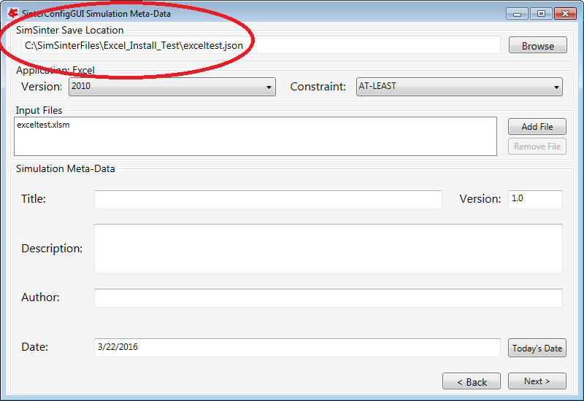

Figure 29: SimSinter Save Location.

1. SimSinter allows the user to restrict the simulator versions that maybe used with the simulation. By default SimSinter will set the restriction to be: at least the newest version of the simulator on the current machine. However, the user may select any version of the simulator supported by SimSinter, and may constrain it in any of the following ways:  
   ANY: SimSinter will attempt to launch the newest version of the simulator available, and will not throw an error, no matter which version is actually launched.  
   AT-LEAST: SimSinter will launch the newest version of the simulator available, but it will throw an error if the version launched is older than the recommended version.  
   REQUIRED: The REQUIRED constraint is not recommended for use with Excel. SimSinter cannot choose which Excel to launch, so it will always launch the newest version available. However, if the version launched is different than the recommended version, SimSinter will throw an error.   
   RECOMMENDED: The RECOMMENDED constraint is not recommened for use with Excel. Because SimSinter cannot choose which Excel to launch, the behavior of RECOMMENDED will be exactly the same as AT-LEAST.   
     
   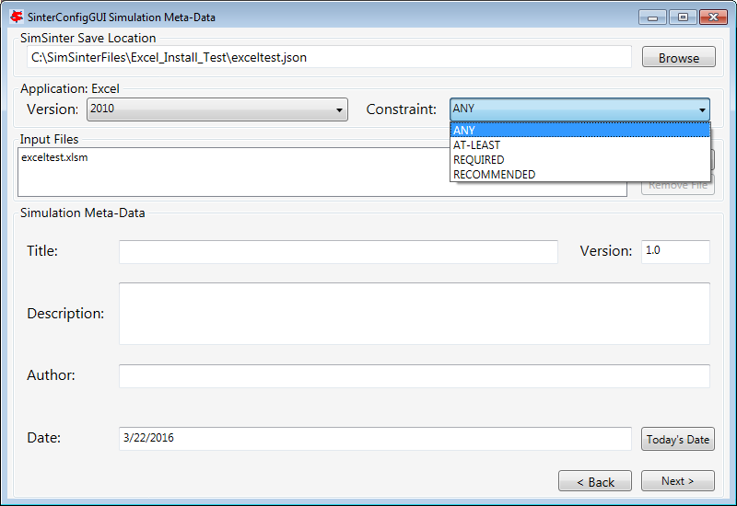

Figure 30: Set Constraints on the Excel Version

1. Some simulations have additional files they require to run. For example, dynamic ACM simulations often have a snapshot.bak file so that the simulation can be restarted from a known state.  
   This simulation does not have any additional files, so a full tutorial will not be given here. For more information see the Dynamic ACM simulation section 4.1.4 . But these additional files may be attached to the simulation via the Input Files section. The simulation file itself is always included in the Input Files, and cannot be removed.  
     
   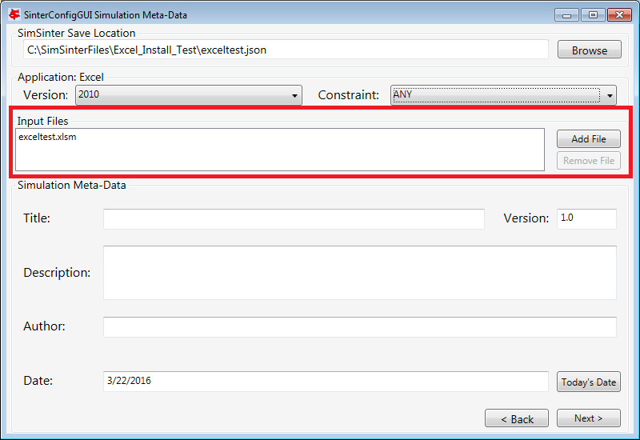

Figure 31: Additional files can be attached

1. Enter the remaining fields to provide the meta-data to describe the simulation that was just opened and then click “Next” (or save, “CTRL+S”).
2. The SinterConfigGUI Variable Configuration Page window displays as shown below. Excel has a single setting, “macro.” If the Excel spreadsheet that is being use has a macro that should be run after Sinter sets the inputs, but before Sinter gets the outputs, enter the macros name in the “Name” text box. If the default is left blank, no macro is run (unless a name is supplied in the input variables when running the simulation).

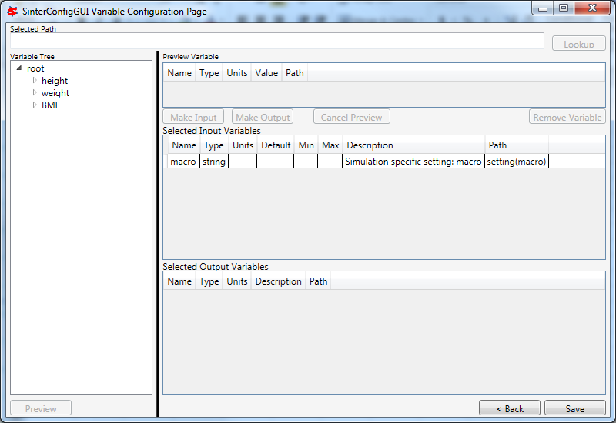

Figure 32: SinterConfigGUI Variable Configuration Page window.

1. The Excel simulation has the same Variable Tree structure as Aspen Plus, as shown in the Figure. Only the variables in the “active section” of the Excel spreadsheet appear in the Variable Tree. If a cell does not appear the user has to manually enter the cell into the “Selected Path” text box.

**Note:** Row is first in the Variable Tree, yet column is first in the path.

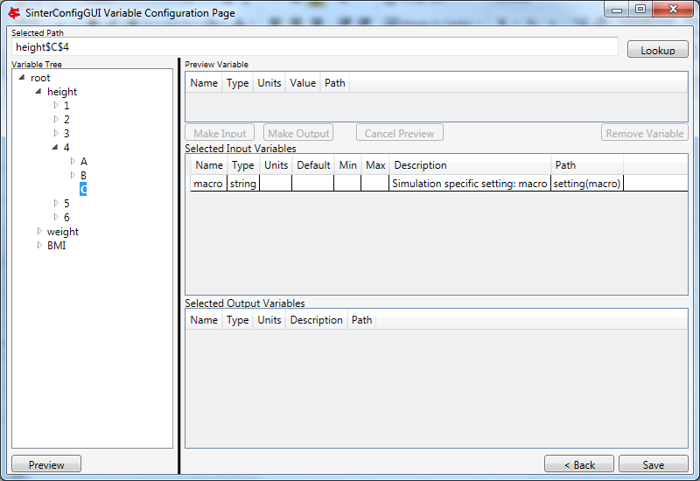

Figure 33: SinterConfigGUI Variable Configuration Page window, Variable Tree.

1. Select an input variable (such as, “height$C$4”) as shown the Figure. A user can enter a “Name,” “Description,” “Default,” “Min,” and “Max” by clicking in the applicable text box.

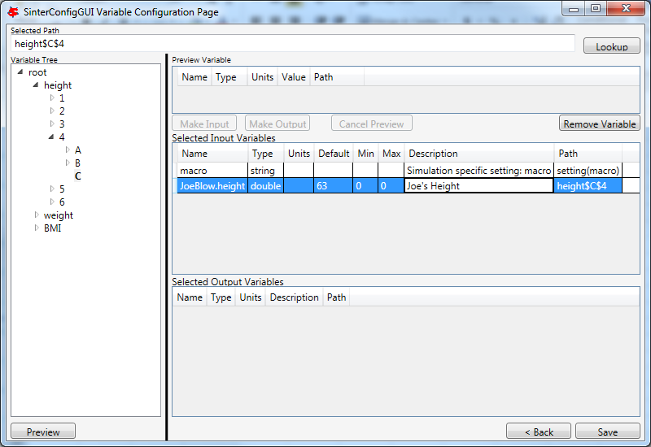

Figure 34: SinterConfigGUI Variable **Configuration** Page window,  
Name, Description, Default, Min, and Max text boxes.

1. Enter an output variable (such as, “BMI$C$3”), by selecting the variables in the Variable Tree, clicking “Preview,” and then clicking “Make Output.”

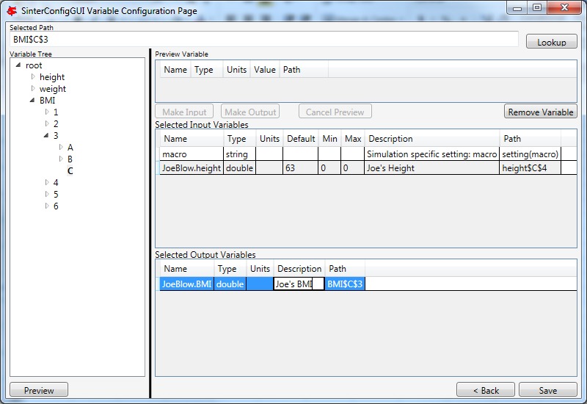

Figure 35: SinterConfigGUI Variable Configuration Page window, Output Variable.

1. The simulation is now set up. To save the configuration file, click “Finish” or press “CTRL+S.” The file is saved to the location that was set on the Meta-Data window. A user can save a copy under a different name, by navigating back to the Meta-Data window using “Back,” and then changing the name. This creates a second version of the file.
   * 1. Creating a Dynamic ACM Simulation
2. Open the “SinterConfigGUI” from the “Start” menu, as shown in Figure 30.



Figure 36: Start menu, SinterConfigGUI.

1. Initially the SimSinter Configuration File Builder splash screen displays, as shown in Figure 31. Either click the “splash screen” to proceed, or wait 10 seconds for the screen to close automatically.



Figure 37: SimSinter Configuration File Builder splash screen.

1. The SinterConfigGUI Open Simulation window displays as shown in Figure 32. Click “Browse” to select the file to open, or type a filename in and click “Open File and Configure Variables” to open the file. The user can either open a fresh ACM simulation (.acmf file) or an existing Sinter configuration file. In these instructions, the ACM test included in the SimSinter installation at C:\SimSinterFiles\ACM_Dynamic_Test\BFB.acmf is opened.

After clicking “Open File and Configure Variables,” it may take a few minutes for the SinterConfigGUI to proceed. The SinterConfigGUI must open the simulator, taking as long as the simulator normally takes to open. For Aspen products that use a networked license server, this may take a few minutes. During that time the SinterConfigGUI remains on the Open File Page and the “Attempting to Open Aspen” message appears at the bottom of the window.



Figure 38: SinterConfigGUI Open Simulation window.

1. The SinterConfigGUI Simulation Meta-Data window displays as shown in Figure 39. And ACM has started up in the background. This is so the user can observe things about the simulation in question as they work on the configuration file. The first and most important piece of meta-data is the “SimSinter Save Location” at the top of the window. This is where the Sinter configuration file is saved. The system suggests a file location and name. SimSinter automatically saves changes to this file. If the built in test files are being used for this tutorial, it is recommend that the name of the save file be changed before proceeding to avoid overwriting the configuration that came with the installation.

Complete the remaining fields to provide the meta-data to describe the simulation that was just opened and then click “Next.” Clicking “Next” automatically saves, but the user can also save at any time by pressing “Ctrl+S.”

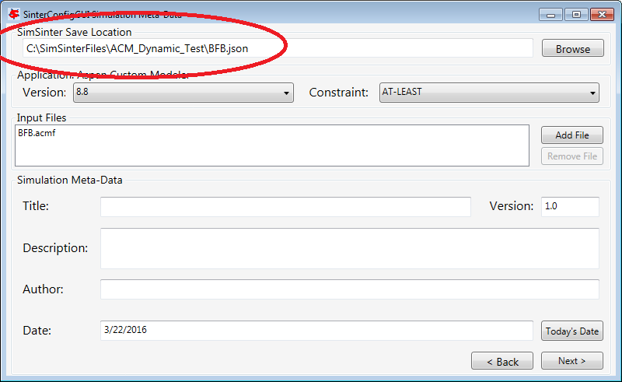

Figure 39: SimSinter Save Location.

1. SimSinter allows the user to restrict the simulator versions that maybe used with the simulation. By default SimSinter will set the restriction to be, at least the newest version of the simulator on the current machine. However, the user may select any version of the simulator supported by SimSinter, and may constrain it in any of the following ways:  
   ANY: SimSinter will attempt to launch the newest version of the simulator available, and will not throw an error, no matter which version is actually launched.  
   AT-LEAST: SimSinter will launch the newest version of the simulator available, but it will throw an error if the version launched is older than the recommended version.  
   REQUIRED: SimSinter will attempt to launch the recommended version, if it does not exist, SimSinter will throw an error and will not run the simulation.  
   RECOMMENDED: SimSinter will attempt to launch the recommended version, if it can’t be found, the newest version available will be launched. The that version is older than the recommended version, SimSinter will throw an error.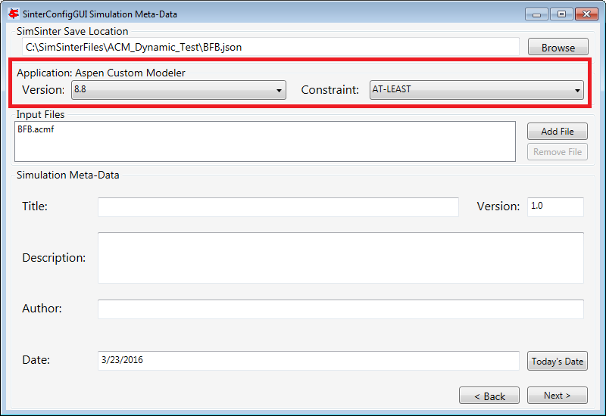

Figure 40:Set Constraints on the Simulator Version

1. In order for the simulation to be able to load snapshots, it requires two files located in the AM_BFB subdirectory: snapshot.bak and tasksnap.bak. These can be attached to the simulation by clinking “Add File” in the “Input Files” box on the Meta-Data Page.  
   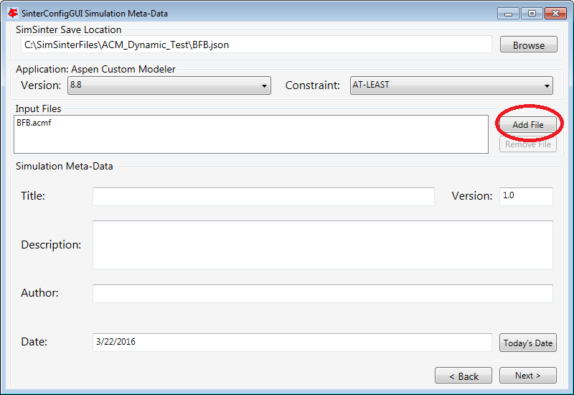

Figure 41: Begin adding additional files to the simulation

1. That will open a file browser window where the files may be selected.  
   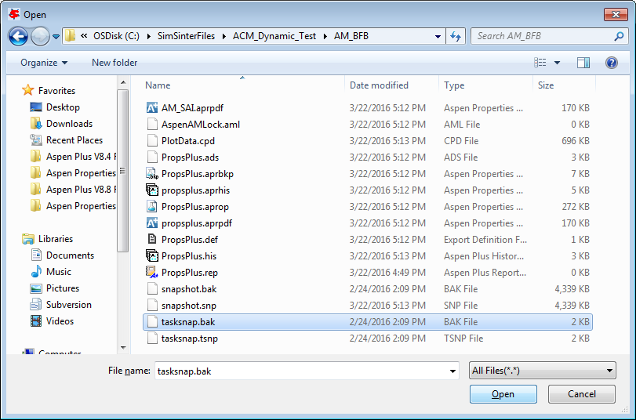

Figure 42: Attaching the tasksnap and snapshot files

1. Then the files will appear, with their relative paths, in the Input Files box.   
   Fill out the rest of the meta-data entries, and click “Next” to proceed.  
   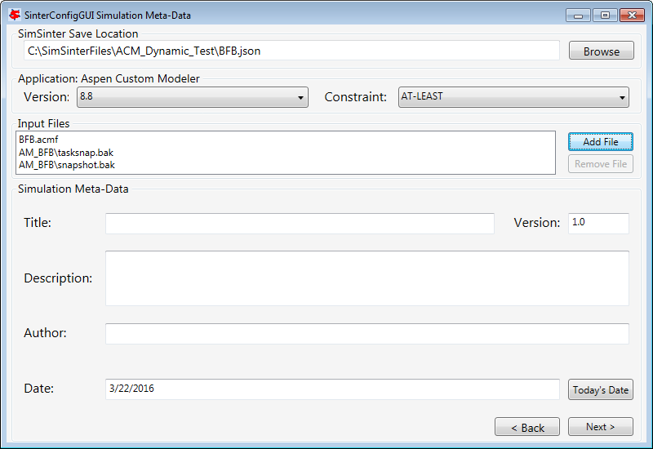

Figure 43: The snapshot files have been attached.

1. The SinterConfigGUI Variable Configuration Page window displays as shown in Figure 44. The ACM Setting variables are already included in the “Selected Input Variables.” For this simulation, change “RunMode” to “Dynamic.”

On the left of the window is a “Variable Search” box. This search is exactly the same as “Variable Find” on the “Tools” menu in ACM. Refer to the ACM documentation for details on search patterns.

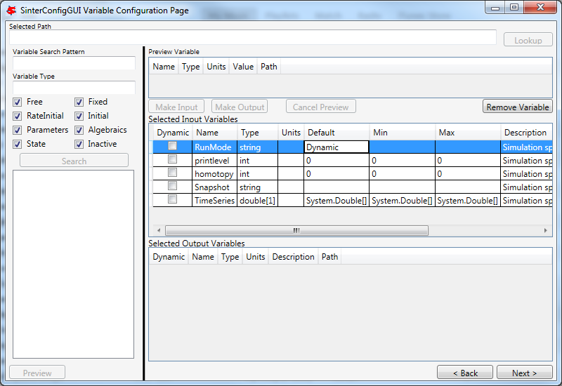

Figure 44: SinterConfigGUI Variable Configuration Page for Dynamic ACM.

1. The “SnapShot” setting gives an optional known starting point for the Dynamic simulation. If “SnapShot” is empty, this Dynamic simulation is simply started from time 0, and whatever steady state solution exists there. If a SnapShot name is provided, the Dynamic simulation will start from that snapshot point, so the TimeSeries must start from after that time.

The “SnapShot” value in the SinterConfigGUI is just a default, when the simulation is actually run a different SnapShot may be provided in the input file.

To select a “SnapShot” the user may first want to confirm which SnapShots are available. The user may click Tools → SnapShots from the ACM drop-down menu to display the window in Figure 45.

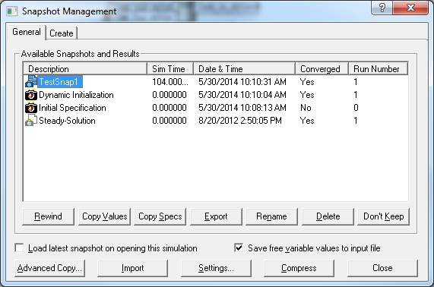

Figure 45: ACM Tools → SnapShot, Snapshot Management window.

1. Enter “TestSnap1” as the name of the SnapShot into SinterConfigGUI as shown in Figure 46.

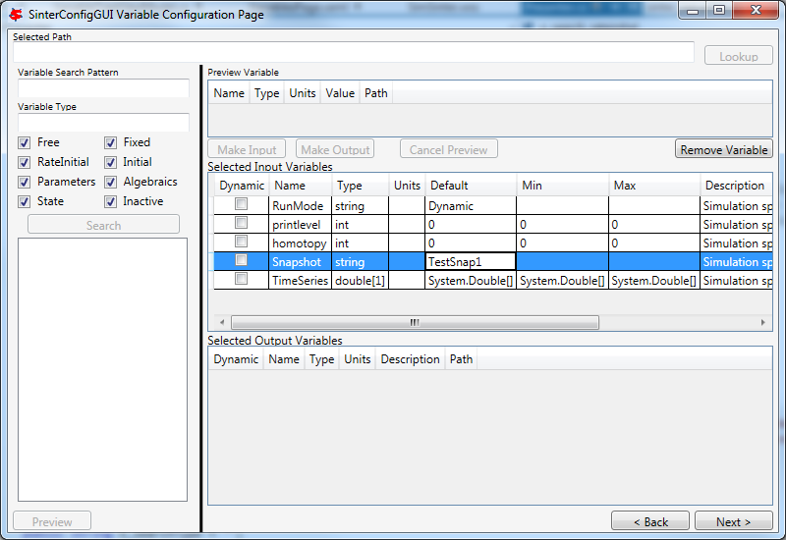

Figure 46: SnapShot setting default set.

1. The search box may be used to find the variables to configure. First search for all the variables in ADSA by entering “ADSA.~” into the “Variable Search Pattern” box and then press “Enter.” This may take a short time, and the user may see the progress window as in Figure 47.



Figure 47: Variable Search, Search In Progress window.

1. Select the “ADSA.A1” variable and make it an input. A1 is a physical constant, so it makes sense to leave it as a Steady State variable. **Do not** click the “Dynamic” check box. This means that the user may set the value of this variable before the simulation starts, and the variable will maintain that value throughout the run.

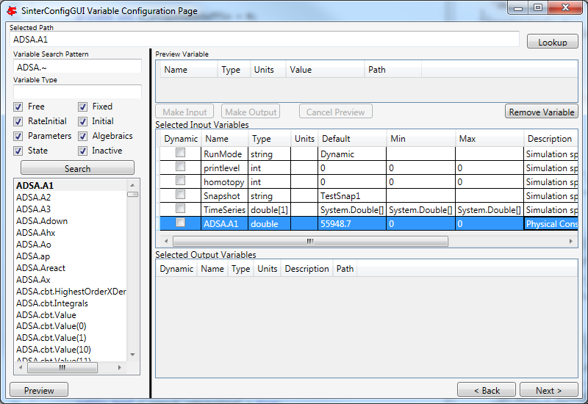

Figure 48: Selecting a Steady State variable.

1. Scroll down in the search window to find “ADSA.GasIn.F.” This defines the amount of gas flowing into the reactor, and is therefore a good choice for a dynamic variable. A dynamic input variable has a new value to be input at the beginning of every time step. To make it an input variable select the “Dynamic” check box.

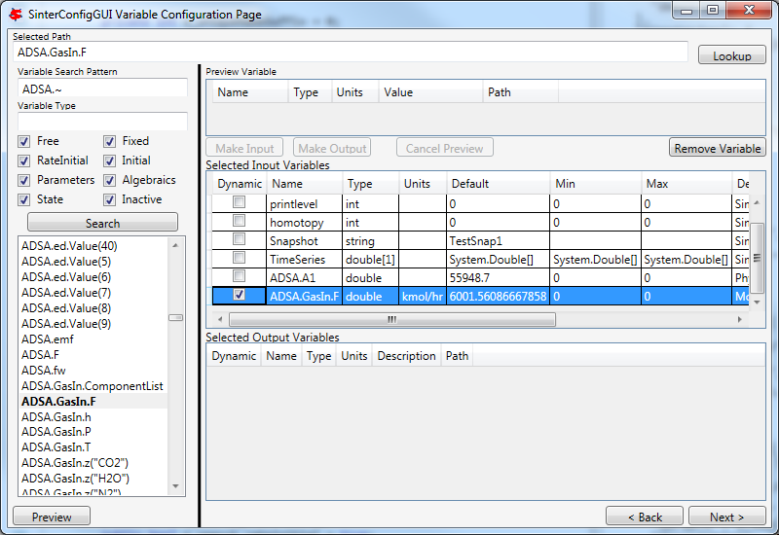

Figure 49: Make a Dynamic variable.

1. A Dynamic Output variable will return a value at the end of every step in the TimeSeries. Select “ADSA.GasOut.T” as an output variable, and then select the “Dynamic” check box to make it a dynamic output variable.

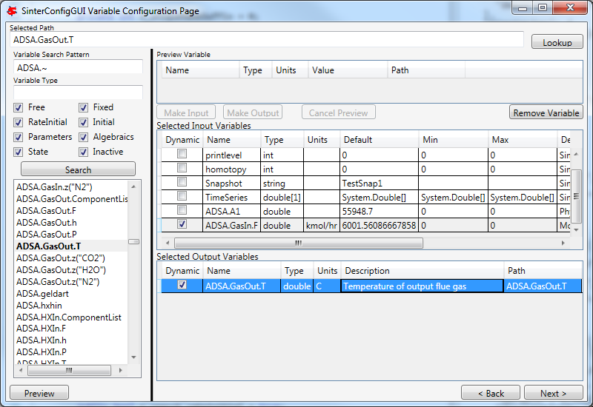

Figure 50: Making a Dynamic output variable.

1. Steady State output variables only output a single value at the end of the simulation. In a Dynamic simulation they are mostly useful for averages and other cumulative or statistical data.

To make a Steady State output, simply select “ADSA.Areact,” make it an output variable, and **do not** select the “Dynamic” check box.

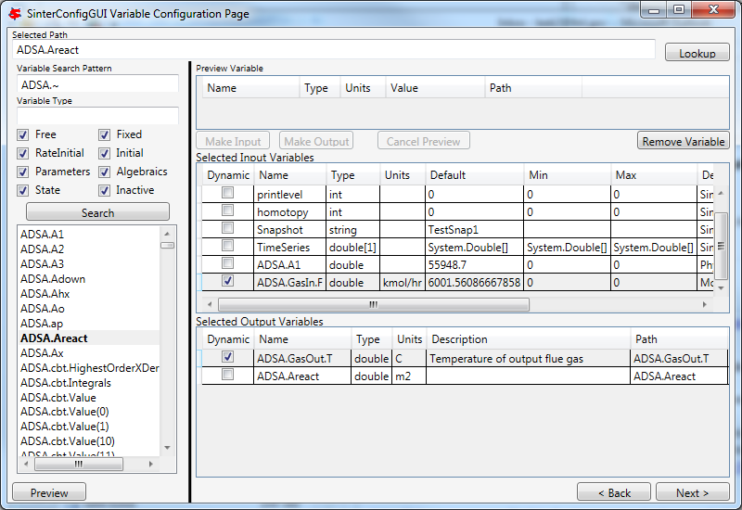

Figure 51: Making a Steady State output variable.

1. Having selected input and output variables, the user can move on. Click “Next”. This displays the Vector Default Initialization window. This window only appears if there are vectors in the set of input variables. For Dynamic simulations the TimeSeries is always an input vector. The user can set up a default TimeSeries here.

However, keep in mind that most tools that use Dynamic simulation, such as DR-M builder, do not require a default time series to be defined. DR-M builder defines a TimeSeries in the input file for every simulation. If the simulation is being configured for use with DR-M builder, the TimeSeries may simply be ignored.

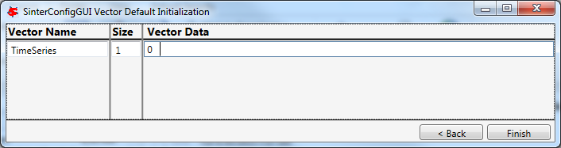

Figure 52: Vector Default Initialization window.

1. The TimeSeries is the only vector where the length may be changed. Change the length to “4.” The default SnapShot starts at 104, so the first value in the time series defines the end of the time step starting at 104, so the first value must be strictly greater than 104, and the values must increase monotonically from there. Simply enter the values into the text boxes.

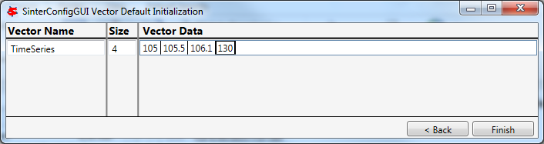

Figure 53: A default TimeSeries.

1. The simulation is now set up. To save the configuration file, click “Finish” or press “CTRL+S.” The file is saved to the location that was set on the Meta-Data window. A user can save a copy under a different name, by navigating back to the Meta-Data window using “Back,” and then changing the name. This creates a second version of the file.
   1. Setting up Microsoft Excel → SimSinter

Description

Microsoft Excel can be used as an easy interface to SimSinter. A user who is familiar with Excel may prefer this option for small local sets of runs, although FOQUS is the preferred method.

Below are five tutorials about using the Excel → SimSinter interface. The first three are examples of running Excel with specific simulators, the fourth is how to make an Excel spreadsheet for a simulation, and the last is running sets from Excel.

**Note:** Some configurations of Windows 7 break the Excel → SimSinter interface. If this issue occurs, the other features of SimSinter work, but the Excel → SimSinter interface fails stating Excel could not open SimSinter. This issue should be reported to aid in identifying the cause of this issue; refer to Section 8.3 Reporting Issues.

**Note:** If a user receives an Excel error stating “Compile error. Can’t find project or library.”; refer to Section 8.2 Known Issues. This fix only needs to be performed one time for each spreadsheet, as long as the spreadsheet is saved after performing the fix.

Aspen Custom Modeler

The ACM test simulates a simple Flash column for the distillation of etOH from H2O.

1. Navigate to the “C:\SimSinterFiles\ACM_Install_Test” directory.
2. Open the “Flash_Example_ACM.xlsm file” using Microsoft Excel. The spreadsheet already has the simulation data filled in for the default case.
3. Click “Run Simulation.” The spreadsheet opens and runs the simulation.
4. When the simulation is complete (it may take up to 60 seconds to open the simulation, but it should only take 1 second to run the simulation), observe that the blue numbers have not changed. In particular, the top blue number “vapor.F” should be “4.6712…”
5. Change the green number “flash.T” from “150” to “200.”
6. Click “Run Simulation.” The simulation should now run in about 1 second since the simulation is already open.
7. Observe that the blue numbers have changed. In particular, observe that the top blue number, “vapor.F” is now “9.0795…”
8. Optionally, change the green numbers to observe further changes in the resulting blue numbers.
9. Close Excel, which automatically closes the simulation.

Aspen Plus

The Aspen Plus test simulates a simple Flash column for the distillation of etOH from H2O.

1. Navigate to the “C:\SimSinterFiles\Aspen_Plus_Install_Test” directory.
2. Open the “Flash_Example_AP.xlsm” using Microsoft Excel. The spreadsheet already has the simulation data filled in for the default case.
3. Click “Run Simulation.” The spreadsheet opens and runs the simulation.
4. When the simulation is complete (it may take up to 60 seconds to open the simulation, but it should only take 1 second to run the simulation), observe that the blue numbers have not changed. In particular, the top blue number “vapor.F” should be “4.6712…”
5. Change the green number “flash.T” from “150” to “200.”
6. Click “Run Simulation.” The simulation should now run in about 1 second since the simulation is already open.
7. Observe that the blue numbers have changed. In particular, observe that the top blue number, “vapor.F” is now “9.0796…”
8. Optionally, change the green numbers to observe further changes in the resulting blue numbers.
9. Close Excel, which automatically closes the simulation.

Microsoft Excel

The Microsoft Excel test uses Excel to perform a simple Body Mass Index calculation. The body mass calculation is done with a VBA macro on the spreadsheet, “RunSinter,” hence the “macro” input on the left of the spreadsheet. The height.vector calculations are done with simple in sheet arithmetic (to demonstrate both methods of doing Excel calculations).

1. Navigate to the “C:\SimSinterFiles\Excel_Install_Test” directory.
2. Open the “BMITestDriver.xlsm” file (the “exceltest.xlsm” file is the “simulation”). The spreadsheet already has the simulation data filled in for the default case.
3. Click “Run Simulation.” The spreadsheet opens and runs the simulation.
4. When the simulation is complete (the simulation should take about 1 second), observe that the blue numbers have not changed. In particular, observe “BMI.joe.” Joe has an astronomical BMI of “122.0486…”
5. Change Joe’s height to a more reasonable number of inches (for example, 64).
6. Click “Run Simulation.” The simulation should now be instantaneous.
7. Observe that “BMI.joe” has changed to a more svelte “17.1630.”
8. Close Excel, which automatically closes the simulation.

Making a New Microsoft Excel Spreadsheet for the Simulation

1. The Excel template should be installed at C:\SimSinterFiles\SimSinter_Excel_Template\SimSinter_Excel_Template.xlsm.

Copy this file to the desired location to work in. A suggested location is the same directory as the simulation file and the Sinter configuration file.

1. Navigate to the directory that the template was copied to.
2. Open the “Template” in Excel.
3. Type the name of the setup file into cell “C2.”
4. Click “Draw Interface Sheet” (the green button).
5. Click “Yes” to continue. The values for a default simulation are then filled in. (Inputs are green and outputs are blue.)
6. Change some green values.
7. Click “Run Simulation.” Observe the changes in the blue numbers when the run completes.

Running Multiple Runs (a Series) with Microsoft Excel → SimSinter

With the Excel spreadsheet a user can do a local series of runs. Only one simulation runs at a time, it is not as fast as the Gateway, but running locally has some advantages. It may even be faster than the Gateway for short series.

For this tutorial the Flash Example is used in the install tests.

1. Open “C:\SimSinterFiles\ACM_Install_Test\Flash_Example_ACM.xlsm.” (The Aspen Plus test works as well, although the user needs to adjust the cells. The Aspen Plus test should be used if the user only has an Aspen Plus license.)
2. Switch to the “Series” sheet in the Excel spreadsheet.
3. Delete Columns “F” and “G,” as they are examples.
4. Insert the following input:

* C7: Flash.T Name of the input, the macro does not use this
* D7: Interface!C17 Indicates to the macro where to place this input (C15 on Aspen Plus)
* E7: input Indicates to the macro this is an input
* F7: 180 Value for Flash.T for the first run
* G7: 200 Value for Flash.T for the second run

1. Insert the following output:

* C8: vapor.F Name of the output, the macro does not use this
* D8: Interface!G10 Indicates to the macro where to get the output from
* E8: output Indicates to the macro this is an output

1. Fill in the “Run id -->” row (Row 4). The macro uses this row to determine how many runs to perform. The macro continues performing runs until this row is empty. Since there are two runs set up in this example, values are needed in cells “F4” and “F5.” The values do not matter, but may be useful user documentation. The resulting spreadsheet should look Figure 44.

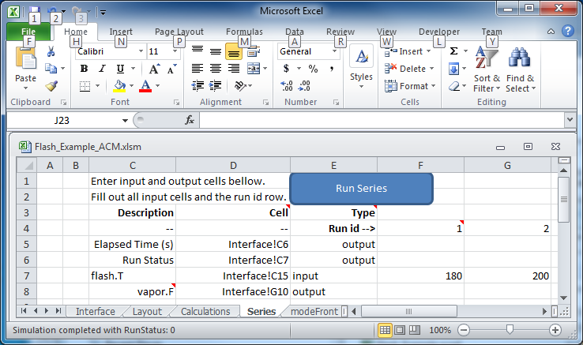

Figure 54: Microsoft Excel, Flash_Example_ACS.xlsm.

1. Click “Run Series.” The result should look like Figure 45.

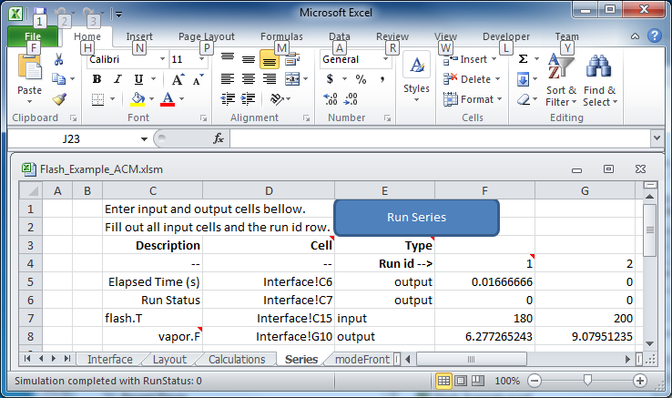

Figure 55: Microsoft Excel, Flash_Example_ACS.xlsm results.

A series of two runs is completed.

* 1. Using CSVConsoleSinter

Description

CSVConsoleSinter was written specifically to enable sets of local runs for a particular optimization package, but it can be handy just because .csv is such a common format. Run CSVConsoleSinter with no arguments for full usage information.

CSVConsoleSinter takes three arguments:

1. A JSON SinterConfig
2. A CSV input file, each column is an input, each row is a run
3. A CSV output file, consisting of a single row, the name of the outputs expected

**Note:** One of the output variables should be “status” which is 0 if the run succeeded, the variable is another number if the run failed.

For this tutorial the .csv in C:\SimSinterFiles\CSVConsoleSinter_Tutorial and the simulation files in C:\SimSinterFiles\ACM_Install_Test are used. (The Aspen Plus example in C:\SimSinterFiles\AspenPlus_Install_Test can also be used by adjusting the relevant filenames.)

The user should view the input and output files before and after running CSVConsoleSinter to understand what happened during the run. The Flash_Example_Output.csv file should match the Flash_Example_Output_Correct.csv file after running CSVConsoleSinter.

Example

1. cd C:\SimSinterFiles\ACM_Install_Test
2. Run: “C:\Program Files (x86)\CCSI\SimSinter\CSVConsoleSinter.exe”   
   Flash_Example_ACM.json   
   ..\CSVConsoleSinter_Tutorial\Flash_Example_Input.csv  
   ..\CSVConsoleSinter_Tutorial\Flash_Example_Output.csv
3. Compare the Flash_Example_Output.csv file and the Flash_Example_Output_Correct.csv file to ensure they match.
   1. Using ConsoleSinter

Description

ConsoleSinter takes the inputs and outputs in the same JSON format as the Gateway. ConsoleSinter is mainly used in code debugging, but can be useful to users. TurbineClient has tools for converting PSUADE and CSV format to and from JSON. Run ConsoleSinter with no arguments for full usage information.

This tutorial has the same idea as the CSVConsoleSinter tutorial. The Flash_Example is used and the output is compared to the existing data.

Example

1. cd C:\SimSinterFiles\ACM_Install_Test
2. Run: “C:\Program Files (x86)\CCSI\SimSinter\ConsoleSinter.exe”   
   Flash_Example_ACM.json   
   ..\ConsoleSinter_Tutorial\Flash_Example_Input.json  
   ..\ConsoleSinter_Tutorial\Flash_Example_Output.json
3. Compare the Flash_Example_Output.json file to the Flash_Example_Output_Correct.json file.
   1. Using DefaultBuilder

Description

DefaultBuilder generates a JSON defaults file from the current values in the simulation. DefaultBuilder is generally useful for testing and use with ConsoleSinter. The defaults file generated by DefaultBuilder is passed as inputs to ConsoleSinter, or the defaults to the inputs can be changed using DefaultBuilder. Run DefaultBuilder with no arguments for full usage information.

This tutorial has the same idea as the CSVConsoleSinter tutorial. The Flash_Example is used and the output is compared to the existing data.

Example

1. cd C:\SimSinterFiles\ACM_Install_Test
2. Run: “C:\Program Files (x86)\CCSI\SimSinter\DefaultBuilder.exe”   
   Flash_Example_ACM.json defaults2.json
3. Compare the defaults2.json file to the Flash_Example_ACM_defaults.json file.
4. Understanding SimSinter
   1. Steady State Simulation

The majority of Simulations run on SimSinter are Steady State simulations. Steady State simulations do not have a time component. They simply simulate the simple ideal case of the reactor running at equilibrium according to the provided constants and input variables. Aspen Plus and Excel can only do Steady State simulation. ACM supports both Steady State and Dynamic simulation. gPROMS supports both Steady State and Dynamic simulation, but SimSinter can currently only perform Steady State simulations with gPROMS.

Steady State simulations have a single set of inputs and outputs. SimSinter sets the inputs before the simulation starts, and collects the outputs when the simulation completes and returns them in the output file.

* 1. Dynamic Simulation
     1. Overview

Dynamic simulation is much more complex because it involves time. Dynamic simulation is used to see how the reactor responds to changes over time, and can be used to simulate conditions such as starting up, shutting down, faults in the system, changes in fuel mix, etc. The most important component of the Dynamic simulation is therefore the “TimeSeries” which lists the time steps the simulation will go through.

Dynamic simulation is currently only supported by ACM, and the Dynamic simulation features were designed to meet the needs of the DR-M builder. The dynamic features are general enough that other projects may find the dynamic simulator useful, but more development may be required. Please send an   
e-mail to [ccsi-support@acceleratecarboncapture.org](mailto:ccsi-support@acceleratecarboncapture.org) with any requests for improvements or bugs.

* + 1. TimeSeries

The Dynamic simulation moves through time in accordance with the TimeSeries. The TimeSeries is an array of doubles, where each double represents the time that the time step will END (and the next one will begin). The dynamic output variables are read from the simulator at these breaks, and the input variables are set.

| Time | Simulation Start | TimeSeries Time 1 | TimeSeries Time 2 | TimeSeries Time 3 | TimeSeries Time 4 |
| --- | --- | --- | --- | --- | --- |
| Input | Input 1 set | Input 2 set | Input 3 set | Input 4 set | -- |
| Output | -- | Output 1 read | Output 2 read | Output 3 read | Output 4 read |

* + 1. Snapshot

Snapshots are a feature of ACM that allow Dynamic simulations to be restarted from a saved time and condition. For example, a user may want to run through a fault scenario multiple times with slightly different starting conditions. Saving a snapshot just before the fault scenario allows this to be done efficiently.

To use snapshots from SimSinter, a user must be careful to do three things correctly:

1. Set the Snapshot “input” setting to the name of the snapshot to start from.
2. Set the “TimeSeries” such that the first value is strictly greater than the snapshot time, and the values monotonically.
3. The simulation must be distributed with the “AM_???” subdirectory created by ACM, containing any .bak files found there. ACM stores the snapshots in those .bak files, so if they are not included, ACM will not be able to restore the snapshot.
   * 1. Variables in Dynamic Simulations

Dynamic simulations have four kinds of variables.

1. **Steady State Input Variables** – Steady State input variables are functionally equivalent to the input variables of Steady State simulations. They have a single input value that is set at the beginning of the run and is never changed. Actually, that value is reinserted at each time step break, so if the value changes in the simulation it will be reset back to the initial value at every time step.
2. **Steady State Output Variables** – Steady State output variables are functionally equivalent to the output variables of Steady State simulations. Only the value found at the last time step is returned in the output data. Steady State output variables are mostly only useful for statistical data in Dynamic simulations.
3. **Dynamic Input Variables** – Dynamic input variables have values that change at each time step. Internally Dynamic input variables are represented in SimSinter by an array of the same length as the TimeSeries array. At each time step the input variable in the simulation is updated to the value ad that address in the array.

Currently there is no fine control of ramping the values up and down included in SimSinter. ACM has internal controls for handing the change in input values that may be modified by the user.

Dynamic input variables also only have a single default value for the whole input array. Therefore, a dynamic scalar only has a single default value (e.g., 5) although the input data is represented as an array. As a result, if the user does not provide a Dynamic input variable (as an array) in the input data, that variable will hold its single default value throughout the run as if it was a Steady State variable.

1. **Dynamic Output Variables** – Dynamic output variables return the value of the simulation variable at the end of each time step. Internally Dynamic output variables are represented in SimSinter by an array of the same length as the TimeSeries array. At the end of each time step the output variable in the simulation is read and entered into the correct address in the array of the Dynamic output variable in SimSinter.

Data Layout

The most confusing thing about Dynamic simulation is how the various pieces of data are split between the configuration file and the input file in practice.

* **TimeSeries** – The configuration file may contain a default TimeSeries as a 1 dimensional (1-D) vector of doubles. However, it does not have to. DR-M Builder never uses the default TimeSeries, so in most cases a valid TimeSeries default does not need to be provided in the configuration file.
* **Snapshot** – Similarly, the configuration file also contains a default snapshot name. This can also be overridden in the input file, but DR-M builder rarely bothers to use Snapshots at all.
* **Dynamic Input Variables** – In the configuration file Dynamic input variables have their own section (dynamic-inputs) but otherwise look the same as normal inputs, they have the same data and meta-data in the same layout. The default of a dynamic scalar double is just a single double, **not** a vector.

In the input file there are no separate sections for Dynamic and Steady State variables, they are all in the same section. However, Dynamic input variables have the time dimension, so a dynamic scalar is represented as an array of doubles in the input file, and a dynamic vector is represented as a 2-D matrix of doubles.

* **Dynamic Output Variables** – In the configuration file Dynamic output variables have their own section (dynamic-outputs) but otherwise look the same as normal outputs. They have the same data and meta-data in the same layout.

Dynamic outputs do not appear at all in the input file, but in the output file there is no separation between Dynamic and Steady State variables, they are all in the same section. However, Dynamic output variables have the time dimension, so a dynamic scalar is represented as an array of doubles in the output file, and a dynamic vector is represented as a 2-D matrix of doubles.

1. SIMSinter Configuration File
   1. Overview

The central activity and difficulty of using SimSinter is writing the configuration files. It is assumed that a user with a deep understanding of the simulation being used also writes the Sinter configuration file. Generally this is the person that wrote the Aspen simulation.

The configuration file contains general information about a simulation, the simulation file location, and the variable (input/output) definitions. Typographical errors in the configuration file were a common source of problems when setting up a Sinter interface; therefore, the SinterConfigGUI was built to simplify the creation.

Types

All variables must have a “mode” (i.e., “input” or “output”).

All variables must also have a “primitive type” (i.e., double, integer, or string).

All variables also have a “class” scalar, vector, table, or setting. Class is the most complex dimension because how to specify it varies between the Text and JSON Sinter configuration formats.

* **Scalar** – A single value inputs or outputs. They may have type int, double, or string.
* **Vector** – Contains a series of values of the same type (i.e., they are 1-D arrays). The type is declared as “primativetype[length]” (e.g., “double[201]” declares that variable as a vector or 201 doubles).
* **Table** – Contains a 2-D table of logically related scalars. Table does not have an equivalent type in any simulator, rather, it is a convenience designed for formatting a set of variables in Excel. Table is of little use if SimSinter is not being used with Excel.

In the JSON format tables are unrestricted. Any value in a table may have any type, and be located anywhere in the simulation data tree. Each entry in a table must refer to an already defined scalar in the scalar section of the configuration file.

In Text format tables only doubles are permitted and an individual value location in the simulator data tree must follow a set of rules. However, the Text format table definition is much more concise and writable. It is hard to imagine anyone writing a JSON format table by hand.

* **Setting** – A special scalar class for defining things about how the simulation is run, rather than defining a variable in the simulation. Settings are therefore simulator specific. For example, using SimSinter with ACM enables two settings: “homotopy,” which defines which solver is run, and “printlevel” which defines how much error detail to return. Like scalars, settings may have type int, double, or string.

Naming

The Sinter variables can be organized into a tree using periods in the variable names, for example, the variables: stream-01.T, stream-02.T, stream-01.P, and stream-02.P, stream-01.comp.O2,   
steam-02.comp.O2, stream-01.comp.N2, and stream-02.comp.N2 would be organized into the following tree:

* Root
* stream-01
  + T
  + P
  + comp
    - O2
    - N2
* stream-02
  + T
  + P
  + comp
    - O2
    - N2
  1. Address Strings

Every variable input/output must have a matching address for finding the variable in the simulation. This gets its own section because each simulator has a different Address format, and way to find the address.

An input scalar or vector may have **multiple** address strings. This is useful when a given variable has to be the same in different places in the simulation. For example, a user may want to vary a reaction constant that may be used in multiple blocks.

Address Strings for Tables are not covered in this section as the JSON format does not use Address Strings for Tables. Tables are format specific and are covered in those sections.

Settings are also not covered in this section, as their format is also Text and JSON format specific, and are covered in those sections.

Aspen Plus

All Aspen Plus variables are held in the Aspen Plus data tree. The variables have addresses to identify them in the tree. The variables are “\” separated and of the form: \Data\Streams\FEED\Input\TEMP\MIXED.

Unfortunately, these addresses are not easy to find inside Aspen Plus. They cannot be identified from inside the Data Explorer. A user must use the Variable Explorer. The Variable Explorer is found at Tools → Variable Explorer.

The Variable Explorer gives a tree view of the data. Open Root → Data. From there a user can find Streams, Blocks, etc. When the user finds the desired node, the user can copy the node address out of the second box below “Path to Node.” It reads: Application.Tree.FindNode(“\Data\Blocks\FLASH\Input\  
DIAMETER”). Copy and paste the portion within the quotes to the “SinterConfigGUI Selected Path” text box, or just navigate through the Variable Tree to the same location.

An experienced Aspen Plus modeler should do fine with this, but a less experienced modeler may need to consult the documentation or request help.

Aspen Custom Modeler

All ACM variables are held in a tree, but the tree is not as obvious as the Aspen Plus tree. In ACM, the flowsheet is the root of the tree, so any flowsheet variables are identified by name. Other variables use “.” separated addresses of the form: Flash.o_port_liq.T.

This variable breaks down to: The Flash Block → The liquid multiport → The temperature.

Generally these addresses can be discovered pretty easily. Open the “AllVariables Table” on the block or stream of interest. Inside the table is a list of variables (the ones that are not hidden). Identify the desired variable on that table. Then write “blockName.VarName” in the “Selected Path” section of the SinterConfigGUI. An even easier way is to use the search function built into ACM and the SinterConfigGUI.

For example, given a stream “Liquid,” double-click the stream in the flowsheet. Find the Ethanol composition “z(“ETHANOL”)” in the table. The resulting address is “Liquid.z(“ETHANOL”).”

Address strings for vectors are similar. If the “AllVariables Table” is opened and contains a series of values with the same name except for a trailing number in parenthesis that is a vector. For example: ADSA.db.Value(0), ADSA.db.Value(1)… ADSA.db.Value(200). The address of that vector is “ADSA.db.Value.” When writing the SinterConfig file, do not forget to include the length of the vector correctly in the type. Since that vector is “0..200,” the type is “double[201].”

Microsoft Excel

For Excel define the cell to set or get data from by “Worksheet$Column$Row.” (The “$” is used because Excel uses “$” as a separator to denote absolute addresses.)

If the user has a worksheet named “weight” and wants to access cell “C2” in that worksheet, the Sinter address is: “weight$C$2.”

Vectors are assumed to proceed left to right, and the address is the address of the first value. If a vector has type “double[3]” and an address “height$A$6,” the three values are at addresses: “height$A$6,” “height$B$6,” and “height$C$6.”

* 1. Settings

Each supported simulator has a set of supported settings. The list of possible settings for any simulator is enormous. Therefore, rather than attempting to either enable them all, or predict what users may need, they have been added as required.

Aspen Plus

There are currently no settings for Aspen Plus.

Aspen Custom Modeler

* RunMode: String. Default “Steady State”

RunMode determines the run mode of the simulation. The possible values are “Steady State,” “Dynamic,” and “Optimization.”

* homotopy: Int. Default: 0

If 1, the solver is set to the homotopy solver, and all of the inputs are set as homotopy targets.

If 0 (or unused), the standard solver is used, the inputs are set directly, and the simulation is solved directly.

* printlevel: Int. Default: 0

Sets the level of error reporting. 0 provides the least detail on errors. 5 provides the maximum detail. (**Note:** 5 can provide so much detail on an error that the simulation can take an extremely long time returning all of the error messages.)

* TimeSeries: double[]. Default: 0

Only used for Dynamic simulation. Sets the end time of each time step of the Dynamic simulation. Dynamic variables are set and read at these times.

* Snapshot: String. Default “”

Only used for Dynamic simulation. Names the snapshot to start the Dynamic simulation from. If left as an empty string the simulation will start from time “0.”

If Snapshots are used the simulation must be distributed with the .bak files in the “AM_???” subdirectory.

Microsoft Excel

* Macro: String. Default: “”

SimSinter can optionally call a macro in Excel to perform the “simulation” desired. This setting gives the name of the macro to run. For example, in the included BMI example, the macro is “RunSinter.”

If no macro should be run (all calculations are done “in sheet.”), the default empty-string does not run any macro.

* 1. Additional Variable Information

Variables have some additional information that may be associated with them. Some of this data is handled differently in the Text and JSON Sinter configuration formats.

* **default** – The simulation writer can include a default value for input variables in the simulation. This default is optional in the Text format, but is required in the JSON format.

Because defaults are not required for the Text format, ConsoleSinter requires a separate defaults file when a Text format Sinter configuration is used.

If SinterConfigGUI is used, the defaults in the JSON configuration are pulled from the current values of the simulation.

The JSON configuration also has defaults for the outputs. The defaults are pulled from sim when it is run with the default inputs. The idea is that these are canonical outputs, and can be useful for comparison.

* **units** – The units entry gives the expected unit of measurement for this variable. The input file also enables a unit of measurement to be defined. If the unit in the input file is different but compatible with the unit in the Sinter configuration file, SimSinter automatically converts the input value to the expected unit type.

Units is a required entry in the JSON format, although it may be empty (“” or null) for unit-less values.

The SinterConfigGUI automatically fills in the units values with the simulation defaults when it is run with Aspen Plus or ACM. Excel cannot provide this information; therefore, the configuration writer should provide the values if possible by typing them into the units field.

* **min** – Min (minimum) and max (maximum) are both optional in both formats. Min and max provide a suggested range for the user to vary a given variable. A modeler may have some insight into how a variable might behave in the real world. A user may value this information, but is also free to ignore it.

For example, a modeler may expect some cooling water to be 25°C on average, but the modeler may also know that the cooling water may, in reality, vary between 15°C and 40°C. Therefore, the modeler may set: default: 25 min:15 max: 40.

The user may ignore this advice, and, vary the value 0C-20C in their experiment. Min and max are just suggestions, but may be valuable information.

* **max** – (maximum) See min above.

See the Flash Example configuration files for examples of how this information is used.

* 1. JSON Sinter Configuration Format

Meta-Data features

The JSON Sinter Configuration format contains multiple items of file or simulation meta-data that help describe the simulation, the configuration, and how it is used. All of these meta-data features are contained in the top level of the file, they are not bound into sections like the variables are.

1. Every file must declare it’s file format version.  
   There are currently 2 JSON file format versions (there is also an older, deprecated, “text” format.)  
   The first JSON format was version 0.2. It is indentified with:  
   "filetype" : "sinterconfig",  
   "version" : 0.2,  
     
   The new JSON file format is 0.3. It is identified with:  
   "filetype": "sinterconfig",  
   "filetype-version": 0.3,
2. Each file has a set four meta-data entries to describe the file that are defined by the user:  
   "title": “This is a nice short title for the simulation”,  
   "author": “This is the person who configured the simulation”,  
   "date": "3/15/2016",  
   "description": “This is a long, detailed field covering everything else users should know”,
3. The file also has a version number for the configuration itself. It defaults to 1.0 when the file is first created, and will automatically increment each time the file is edited in SinterConfigGUI, but the user can also set it manually  
   "config-version": "1.0",
4. The “application block” says which simulator the simulation runs under, and has optional simulator version constraints, as described in the tutorial sections.  
   In the file the “internal version number” of the simulator is used. Many programs have version names that are used for marketing purposes, and version numbers that are used internally. For example, Microsoft Excel 2010 is actually version 14.0. SinterConfigGUI attempts to show the marketing name, as that is more familiar to users, but internally SimSinter uses the “real” version numbers.  
   "application": {  
    "name": "Aspen Custom Modeler",  
    "version": "34.0",  
    "constraint": "AT-LEAST",  
   },
5. The “model block” declares the main simulation file to open with the simulator. It also includes a hash to verify that any file found on the file system is actually the file intended at configuration time.   
   "model": {  
    "file": "Flash_Example.acmf",  
    "DigestValue": "8eede360cab95e12376c2f9d9013a794b4e86b5d",  
    "SignatureMethodAlgorithm": "sha1"  
   },
6. The “input-files” block contains all the OTHER input files that may be required by the simulation. Some simulations require extra files beyond the model file, such as DLLs containing extra functionality, or snapshot files for reloading the simulation. This block is often empty, and it didn’t even exist in the 0.2 version of the configuration file format.  
   It has a similar format to the model block, input-files also includes a file hash signature, although if one cannot be generated, it may be left out.  
   Empty Case:  
   "input-files": [],  
   Snapshot files example:  
    "input-files": [  
    {  
    "file": "AM_BFB\\snapshot.bak",  
    "DigestValue": "1e558b7328428907b572ee13d0684b75832e2bce",  
    "SignatureMethodAlgorithm": "sha1"  
    },  
    {  
    "file": "AM_BFB\\tasksnap.bak",  
    "DigestValue": "7554617594ef7e2f7efb7dd4b8f9bdfce5e03466",  
    "SignatureMethodAlgorithm": "sha1"  
    }  
    ],

JSON Format Sections

Rather than mixing input, outputs, and settings as is done in the Text format, the JSON format separates them into separate optional sections. There are **seven** such sections in the JSON Sinter configuration format: Settings, Inputs, Outputs, Dynamic-Inputs, Dynamic-Outputs, TableInputs, and TableOutputs. These sections are all optional. Different simulations may select to not use any of the sections (although if “TableInputs” is used the user also needs an “Inputs” sections).

1. **Inputs** – Inputs have seven entries (not including the name, which is the key to the data): type, description, units, path, default, min, and max.

min and max are the *only* optional entries. min and max define a range suggested by the simulation writer for UQ variance.

There may be multiple address strings. In the JSON format, the Addresses are held in a JSON Array, so it is simple to add additional strings.

Names are given in “.” separated tree format as previously described. absorber.input.dia and absorber.input.ht could be visualized as:

absorber

|-> input

|-> dia

|-> ht

1. **Outputs** – Outputs have five entries (not including the name): units, path, type, description, and default. Default is optional for outputs. Default can be useful, if included, for comparing the output of a simulation to a canonical value, or for input to the Heat Integration GAMS simulation.
2. **Dynamic-Inputs** – Dynamic Inputs are exactly the same as normal Inputs in the configuration file. They are just contained in a different section. However, in the input file time is added as a dimension to the variable. So scalar variables are represented as 1-D vectors in the input file, and vectors are represented as 2-D matrices in the input file.
3. **Dynamic-Outputs** – Dynamic Outputs are exactly the same as normal Outputs in the configuration file. They are just contained in a different section. However, in the output file time is added as a dimension to the variable. So scalar variables are represented as 1-D vectors in the output file, and vectors are represented as 2-D matrices in the output file.
4. **Settings** – Settings have three fields (not including the name): description, default, and type.
5. **InputsTables** – There are two sections for defining tables, InputTables and OutputTables. Tables cannot have mixed inputs and outputs in the same table. Recall that tables are completely optional; tables are only for improving formatting in Excel. Sometimes it is easier to read a given set of data as a table than in a tree format.

A table has a name, and three internal arrays: rows, columns, and contents.

1. Rows: 1-D array of row labels for users.
2. Columns: 1-D array of column labels for users.
3. Contents: 2-D array of the variables used to make up the table. (These names must match the names defined in either the inputs or the outputs section. **Note:** In the example they do not match to save space and make the example easier to read.)
4. **OutputsTables** – See the *InputTables* section. It is exactly the same, except that all of the used variables must be output variables.

JSON Sinter Example

The following is a simple example of a JSON Sinter configuration file. The file is pulled from a real file, but has been shortened.

{

"title" : "ExampleSinterConfig",

"description" : "An Example of What the Future JSON Sinter Config Might Look Like",

"filetype" : "sinterconfig",

"version" : 0.2,

"aspenfile" : "exampleMEA.bkp",

"author" : "Jim Leek",

"date" : "2012-03-13",

"settings": {

"initialize": {

"description": "Warm up the simulation",

"default": 1,

"type": "int"

}

},

"inputs": {

"absorber.input.dia": {

"units": "ft",

"path": ["\\Data\\Blocks\\ABSORBER\\Input\\PR_DIAM\\1"],

"default": 15.4,

"type": "double",

"description": "The diameter of the absorber, initial guess if ds active"

},

"absorber.input.ht": {

"description": "The height of the absorber column",

"min": 10,

"default": 15.4,

"max": 20,

"units": "ft",

"path": ["\\Data\\Blocks\\ABSORBER\\Input\\PR_PACK_HT"],

"type": "double"

}

},

"inputTables" : {},

"outputTables": {

"solvent.output.table": {

"description" : "The Solvent Ouptut Table",

"rows": [

"LEAN-01",

"RICH-01"

],

"contents": [

[

"solvent.output.lean-01.mea",

"solvent.output.lean-01.h2O",

"solvent.output.lean-01.cO2"

],

[

"solvent.output.rich-01.mea",

"solvent.output.rich-01.h2O",

"solvent.output.rich-01.cO2"

]

],

"columns": [

"MEA",

"H2O",

"CO2"

]

}

},

"outputs": {

"abs.output.ic.duty": {

"units": "degF",

"path":

["\\Data\\Blocks\\ABSORBER\\Subobjects\\Pumparounds\\P-1\\Output\\DUTY4\\P-1"],

"default": 12.1,

"type": "double",

"description": "Heat duty of absorber"

},

"solvent.output.lean-01.mea": {

"path": [

"\\Data\\Streams\\LEAN-01\\Output\\STR_MAIN\\MASSFRAC\\MIXED\\MEA"

],

"type": "double",

"default": 0.133889938,

"description": "lean solvent output mea mass fraction",

"units": ""

},

"solvent.output.lean-01.mea": {

"path": [

"\\Data\\Streams\\LEAN-01\\Output\\STR_MAIN\\MASSFRAC\\MIXED\\H20"

],

"type": "double",

"default": 0.661512942,

"description": "lean solvent output H2O mass fraction ",

"units": ""

},

"solvent.output.lean-01.mea": {

"path": [

"\\Data\\Streams\\LEAN-01\\Output\\STR_MAIN\\MASSFRAC\\MIXED\\CO2"

],

"type": "double",

"default": 6.23713113E-08,

"description": "lean solvent output CO2 mass fraction ",

"units": ""

},

"solvent.output.rich-01.mea": {

"path": [

"\\Data\\Streams\\RICH-01\\Output\\STR_MAIN\\MASSFRAC\\MIXED\\MEA"

],

"type": "double",

"default": 0.0340393925,

"description": "rich solvent output mea mass fraction ",

"units": ""

},

"solvent.output.rich-01.mea": {

"path": [

"\\Data\\Streams\\RICH-01\\Output\\STR_MAIN\\MASSFRAC\\MIXED\\H20"

],

"type": "double",

"default": 0.631810932,

"description": "rich solvent output H2O mass fraction",

"units": ""

},

"solvent.output.rich-01.mea": {

"path": [

"\\Data\\Streams\\RICH-01\\Output\\STR_MAIN\\MASSFRAC\\MIXED\\CO2"

],

"type": "double",

"default": 2.24997645E-05,

"description": "rich solvent output CO2 mass fraction ",

"units": ""

}

}

}

1. USAGE Information
   1. Support

For support, e-mail the problem with all of the relevant details to:   
[ccsi-support@acceleratecarboncapture.org](mailto:ccsi-support@acceleratecarboncapture.org).

* 1. SinterConfigGUI Hot-Keys

The SinterConfigGUI is a program that helps users configure SimSinter to work with their simulations. It is a series of pages that are distinct steps in configuring the simulation. Each page has hot-keys that can be used on that page.

* + 1. Initial Page / Open File Page

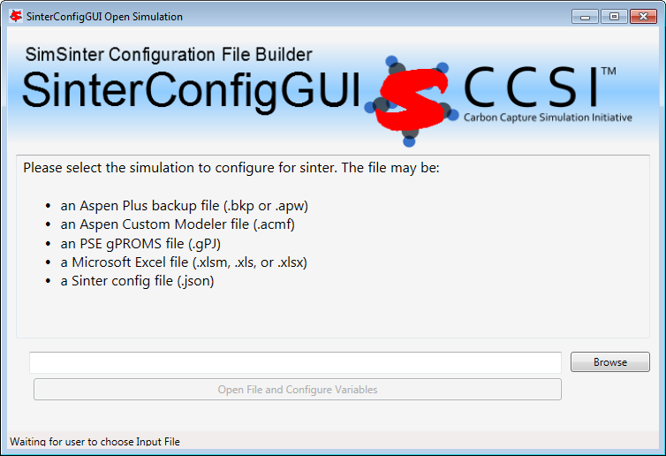

|  |  |  |
| --- | --- | --- |
| Command | Hot Key | Explanation |
| Open file browser | CTRL+O  CTRL+B | Standard Microsoft Open File hot-key  B for “Browse” |

* + 1. Meta-Data Page

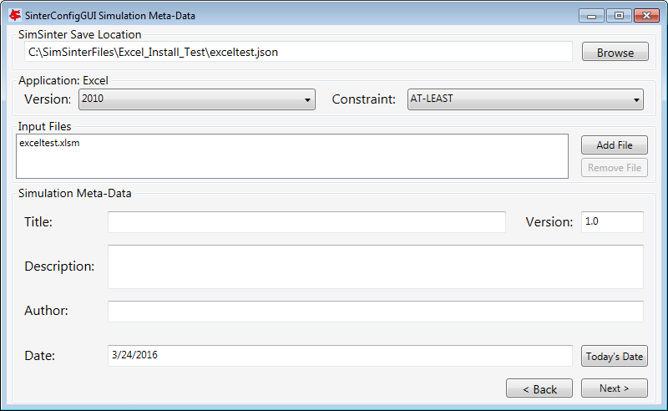

|  |  |  |
| --- | --- | --- |
| Command | Hot Key | Explanation |
| Save (In current Save location) | CTRL+S | Standard Microsoft Save hot-key |
| SaveAs (Browse to new save location) | F12 | Standard Microsoft Save As hot-key |
| Back / Reset SinterConfigGUI | Backspace  Alt-Left | Standard web browser ”back” hot-key  Standard web browser ”back” hot-key |
| Next / Go to Variable Config Page | Shift+Backspace  Alt-Right | Standard web browser ”forward” hot-key  Standard web browser ”forward” hot-key |
| Add Additional Input File | CTRL+ “+”  Insert | Stardard Microsoft “Add Item” hot-key  Opposite of “Delete” |
| Remove File from Additional Input File List | CTRL+ “-”  Delete | Stardard Microsoft “Remove Item” hot-key  Delete |

* + 1. Variable Configuration Page

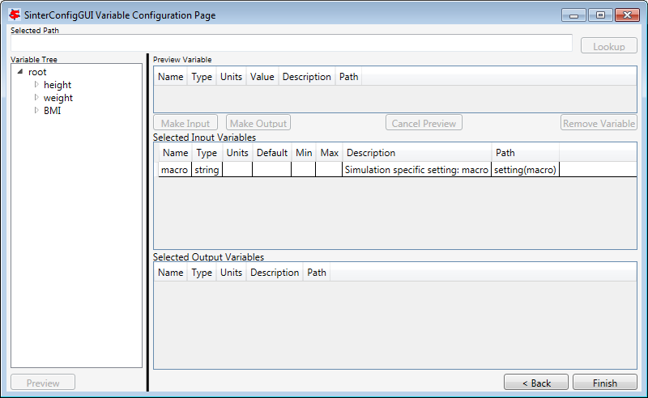

|  |  |  |
| --- | --- | --- |
| Command | Hot Key | Explanation |
| Save (In current Save location) | CTRL+S | Standard Microsoft Save hot-key |
| SaveAs (Browse to new save location) | F12 | Standard Microsoft Save As hot-key |
| Back / Go to Meta-Data Page | Backspace  Alt-Left | Standard web browser ”back” hot-key  Standard web browser ”back” hot-key |
| Next / Go to Meta-Data Page | Shift+Backspace  Alt-Right | Standard web browser ”forward” hot-key  Standard web browser ”forward” hot-key |
| Preview Variable | F2 | Standard Microsoft “Edit Field” hot-key |
| Make Preview an Input Variable | CTRL+I | ‘I’ for “Input” |
| Make Preview an Output Variable | CTRL+O | ‘O’ for “Output” |
| Remove Variable | Delete | Delete |

* + 1. Vector Defaults Configuration Page

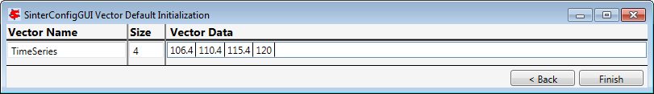

|  |  |  |
| --- | --- | --- |
| Command | Hot Key | Explanation |
| Save (In current Save location) | CTRL+S | Standard Microsoft Save hot-key |
| SaveAs (Browse to new save location) | F12 | Standard Microsoft Save As hot-key |
| Back / Goto Variable Config Page | Backspace  Alt-Left | Standard web browser ”back” hot-key  Standard web browser ”back” hot-key |
| Next / Save and Quit | Shift+Backspace  Alt-Right | Standard web browser ”forward” hot-key  Standard web browser ”forward” hot-key |

* 1. Unit of Measurement Conversion

As of v0.2, SimSinter supports unit conversion on input variables. If a Sinter configuration file defines a unit of measurement for a given input variable, and the Sinter input file declares a different type, and the two types are compatible, the input value are converted to the correct units before being passed to the simulation. If the input file does not provide a unit string (units: “” or units: null) the value is assumed to be in the same units as provided in the Sinter configuration file.

SimSinter displays an error if the Sinter configuration units and input file units are not compatible, or if the input file defines a unit but the Sinter configuration file does not. The lack of units in the Sinter configuration file implies that the expected value is unitless, so defining any unit for it is defining a   
non-compatible.

**Note:** No conversion is provided out the output variables by SimSinter because the input file has no way to define the desired output variable units. This may be provided in a future version.

Aspen Plus and ACM both take F and C as the symbols for Fahrenheit and Celsius. By the international standard F and C represent Farads and Coulombs, °F and °C represent Fahrenheit and Celsius. SimSinter does not accept F and C for Fahrenheit and Celsius; however, a number of symbols are permitted. For example, Celsius can be represented with °C, degC, deg_C, degree_Celsius, celsius, degree_C, degrees_C, degree, degreesC, degsC, and degs_C. SimSinter, SinterConfigGUI, defaults to “degC” to represent Celsius.

If a user has JSON configuration files from earlier versions of Sinter, the user may need to convert the files to use degF and degC. The old versions use the Aspen symbols (F and C).

To practice with the unit conversion, edit the Sinter configuration and input files used in the Units_Test described in the Installation Guide.

If SimSinter does not support a unit type that is being used, e-mail   
[ccsi-support@acceleratecarboncapture.org](mailto:ccsi-support@acceleratecarboncapture.org). An updated version of CCSIUnits or assistance with patching the installed version will be provided.

* 1. Using the Included Command Line Tools

The most common uses of the command line tools are covered in the tutorial. This is a reference to ensure the command line arguments are known:

ConsoleSinter

ConsoleSinter takes either three or four arguments depending on if the user is using a Text or JSON format Sinter configuration file.

* **JSON** – ConsoleSinter <JSON Sinter Config> <Input File> <Output File Name>
* **Text** – ConsoleSinter <Text Sinter Config> <Defaults File> <Input File> <Output File Name>

The Defaults File is a simple JSON dictionary matching names to values. The file can be generated automatically with the DefaultBuilder helper tool.

The Input File can be in input format version 1 or 2. The file can be a single run, or a JSON array of runs (as generated by TurbineClient).

When ConsoleSinter is run an output file is created with the Output File Name, over writing any file that currently uses that name. The file is a JSON array of outputs in output format 2, the same as is returned from the Gateway or TurbineClient.

CSVConsoleSinter

CSVConsoleSinter takes three arguments:

CSVConsoleSinter <JSON Sinter Config> <CSV Input File> <CSV Output File >

The Sinter Config file must be in JSON format.

The Input File is a .csv file with Sinter variable names in the first row, and every subsequent row is a separate run with input values.

The Output File is a .csv file with Sinter variable names in the first row. The subsequent rows are written with the outputs for those variables from each run. Use caution as CSVConsoleSinter overwrites whatever is in the file.

DefaultBuilder

Default builder takes two arguments:

DefaultBuilder <Sinter Config> <Output File Name>

The Sinter Config File can be either in Text or JSON format. It does not matter which, although DefaultBuilder is intended for helping with Text format files.

When DefaultBuilder is run an output file is created with the Output File Name, overwriting any file that currently uses that name. The file is in output format 1, a simple JSON dictionary of input variable names and their matching values from the simulation.

1. Debugging
   1. How to Debug

No software is perfect, and while SimSinter is fairly well tested, some issues are expected.

If a developer would like to add to SimSinter, or fix bugs in the software, the source code can be provided. Request the code by sending an e-mail to [ccsi-support@acceleratecarboncapture.org](mailto:ccsi-support@acceleratecarboncapture.org).

If a user encounters a bug, send a detailed description of the bug, along with a reproducer (if possible) to [ccsi-support@acceleratecarboncapture.org](mailto:ccsi-support@acceleratecarboncapture.org).

* 1. Known Issues

1. If SimSinter has an Error, Sometimes Aspen Remains Open

It is difficult to get a good consistent shut down behavior with Aspen when it or SimSinter encounters an error. Therefore, SimSinter sometimes leaves Aspen open in the background, i.e., there is no open Aspen window, so Aspen is difficult to close.

Generally Aspen closes itself after approximately five minutes in this state, but often the user wants to proceed sooner than that and the open Aspen process is in the way. In this case, end the process via the Windows Task Manager.

1. Open the “Windows Task Manager.” Using “Ctrl+Shift+Esc” is the fastest way to open the Task Manager.
2. Select the “Processes” tab.
3. Select the process to end.  
   ACM: AspenModeler.exe (see Figure 46 below)  
   Aspen Plus: apwn.exe (possibly also apmain.exe if the process does not close by itself)

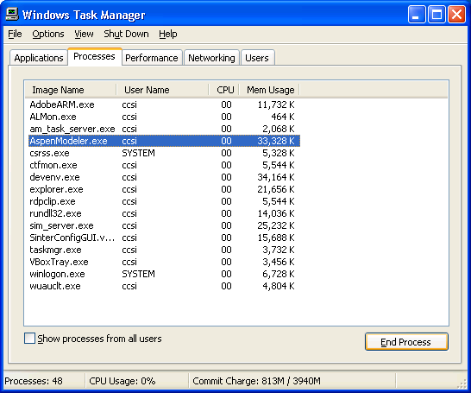

Figure 56: Windows Task Manager, Processes tab, AspenModeler.exe.

1. Click “End Process.”
2. If a Windows pop up dialog box prompts the user to close the program or to debug the program, select the simplest response. (“Yes” close the program, do not debug.)
3. SimSinter does not Attempt to Recover from Aspen not being able to Contact the License Server

SimSinter assumes that opening ACM or Aspen Plus should work on the first try. If the user opens Aspen directly (not with SimSinter) and the license server cannot be contacted, Aspen gives the user the chance to select a different license server.

SimSinter does not offer this option. Therefore, if the license server cannot be contacted, Sinter posts an error stating that it could not open Aspen. The user can fix the license server with the SLM License Manager.

1. Some Windows 7 Configurations Interfere with the Excel → SimSinter Interface

Using Excel to drive SimSinter does not work with some configurations of Windows 7. All of the other SimSinter features work correctly, SinterConfigGUI, FOQUS, etc. This issue should be reported to aid in identifying the cause of this issue; refer to Section 8.3 Reporting Issues.

1. Missing MSVCR100.dll

This is usually an Aspen v7.3 installation problem. If an error message displays referring to “Missing MSVCR100.dll,” the Microsoft Visual C++ 2010 Redistributable Package needs to be installed. The packages can be downloaded online at: <http://www.microsoft.com/en-us/download/details.aspx?id=5555> or can be found via Google.

1. Running SimSinter on Aspen may Interfere with Other Running Aspen Jobs

Neither Aspen Plus nor ACM are intended to be run with another copy of Aspen on the same machine. If a user runs Sinter on Aspen Plus when a copy of Aspen Plus is already open, the interaction may cause strange results. In particular, if the user runs ACM, and then runs ACM through Sinter, closing either copy of ACM also closes the other.

1. Sinter Error: Retrieving the COM Class Factory for Component with CLSID

The error as shown in Figure 47 may display either from the GUI or from Excel. The error means that SimSinter cannot find the CCSIUnits COM interface. This should be unusual, since CCSIUnits is now packaged with SimSinter. If the error occurs try reinstalling CCSIUnits separately.

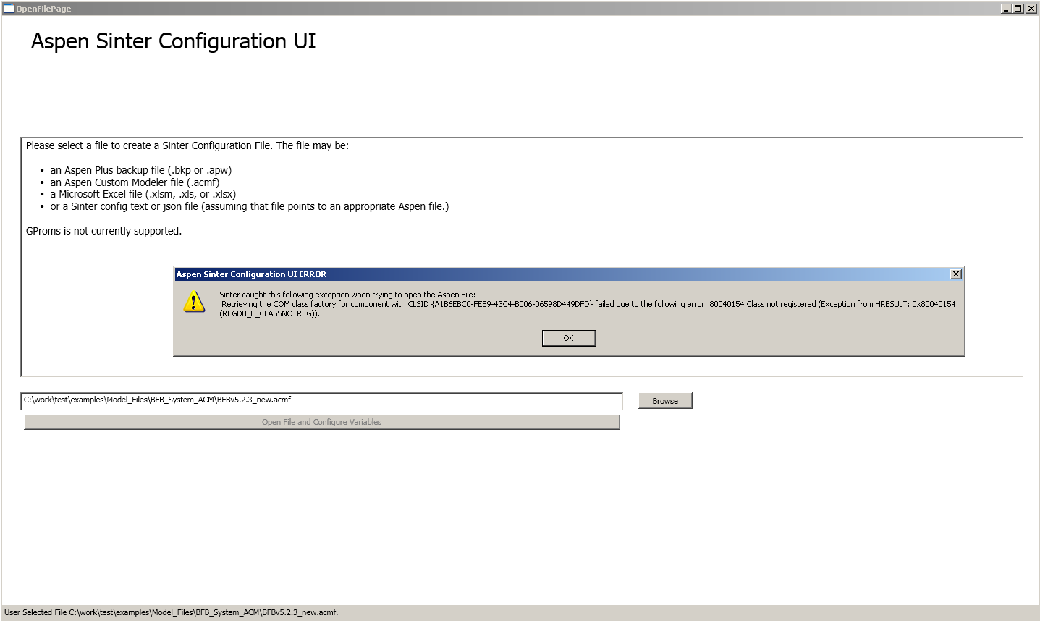

Figure 57: Aspen Sinter Configuration UI ERROR.

1. Excel Cannot Find the SimSinter Library

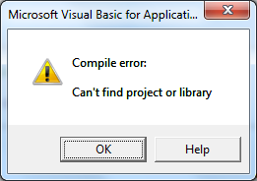

Figure 58: Excel Error Received When Using SimSinter

Sometimes Excel fails to find the SimSinter Library File as shown in Figure 58. Excel attempts to find the library where it was found on the machine the SimSinterInstaller was built on. Depending on 32- or 64-bit, and Windows 7 or Windows XP, etc. the install location can be slightly different. The user may need to indicate in Excel where to find where the library has been installed on the machine. The user only needs to do this once for each spreadsheet, as long as the user saves the spreadsheet after the reference is set.

**Note:** If this procedure does not work the first time, or if the user receives a new error, such as, “user-defined type not defined,” exit Excel, reopen Excel, and then attempt this fix before doing anything else.

If the user receives this error, Excel opens the References window as shown in Figure 49 below. If Excel does not open the window automatically, or if the user is performing this fix from a clean boot up, start by opening the “Visual Basic IDE” by pressing “Alt+F11” or selecting   
Developer → Visual Basic, and then navigate to Tools → References.

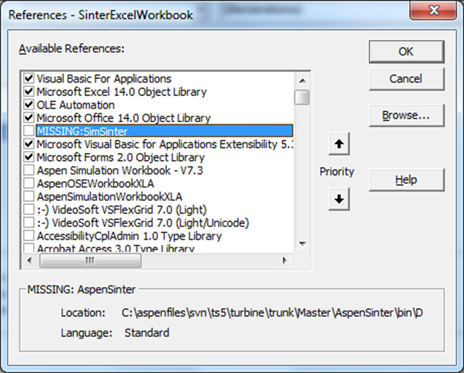

Figure 59: References window, MISSING:SimSinter library.

The SimSinter library is listed as “MISSING.” (AspenSinter is a deprecated name for SimSinter.) Excel needs informed where is the library is located. Unless the user has changed the install path, the library is at:

* Windows XP (32-bit): C:\Program Files\CCSI\SimSinter\SimSinter.tlb
* Windows 7 (64-bit): C:\Program Files (x86)\CCSI\SimSinter\SimSinter.tlb

If using SimSinter_Aspen7.3:

* Windows XP (32-bit): C:\Program Files\CCSI\SimSinter_Aspen7.3\  
  SimSinter_Aspen7.3.tlb
* Windows 7 (64-bit): C:\Program Files (x86)\CCSI\SimSinter_Aspen7.3\  
  SimSinter_Aspen7.3.tlb

If the user has changed the install path the user has to browse to that path. Figures 60–64 demonstrate navigating to the default installation directory to locate the library step-by-step.

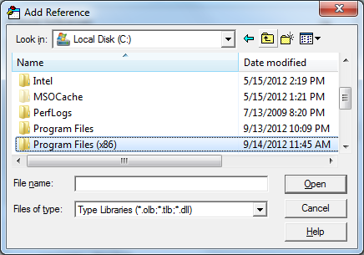

Figure 60: Navigating to the SimSinter library from C:.

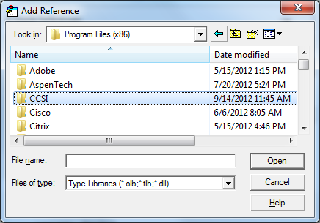

Figure 61: Navigating to the SimSinter library from Program Files.

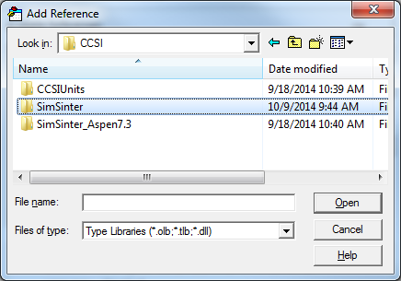

Figure 62: Navigating to the SimSinter library directory.

Double-click “Sinter.tlb” or click “Open.”

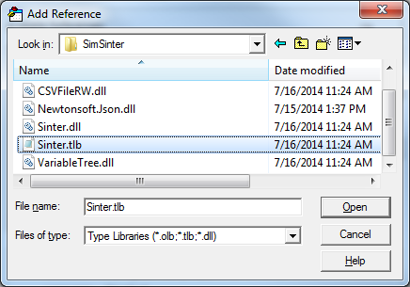

Figure 63: Selecting the Sinter.tlb library.

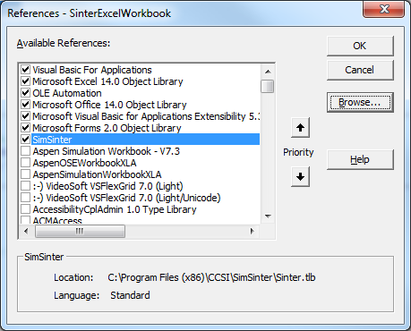

Figure 64: SimSinter library is selected.

The “SimSinter” check box is selected in the References window (Figure 64). If the check box is cleared, select the check box.

Close the References window and the code window (if the window is open).

Save the spreadsheet, and then try running the simulation again. The simulation should now run with no errors.

1. Excel Interface Reports “Automation Error”

This error appears to be due to a Microsoft update of some kind, not a SimSinter bug. It will appear when trying to run or open a SimSinter simulation from inside Excel. The fix is simple, de-reference and then re-reference the “OLE Automation” reference.

1. Start by opening the “Visual Basic IDE” by pressing “Alt+F11” or selecting   
   Developer → Visual Basic.

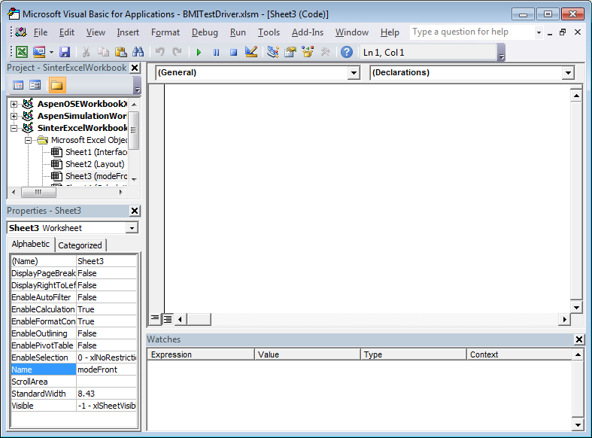

Figure 65: Excel’s Visual Basic window.

1. Select Tools → References.

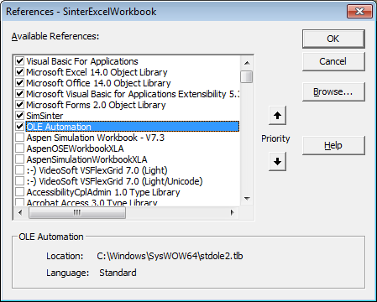

Figure 66: References window.

1. Clear the “OLE Automation” check box and then click “OK.”

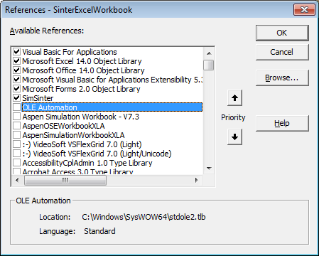

Figure 67: Cleared “OLE Automation” check box.

1. Re-open Tools → References, select the “OLE Automation” check, and then click “OK.”



Figure 68: Selected “OLE Automation” check box.

1. Close the Visual Basic window and navigate back to the normal Excel worksheet. The simulation should now work.
2. Aspen Plus and ACM Vector Units are Assumed to be the Same for the Whole Vector

ACM enables individual vector entries to have different display units. A vector of temperature could have some of the values displayed in °F and some in °C.

SimSinter always gets values in their display units, not their base units. SimSinter would return the vector to the user with some values in °F and some in °C. However, SimSinter would report the units of the entire vector as the units of the first value. If the first value is displayed in °C, but all of the rest of the values are displayed in °F, SimSinter reports the whole vector as °C. SimSinter does not check the units of every value in the vector because it makes SimSinter unacceptably slow.

It is recommended to not mix units inside a vector.

1. Missing api-ms-win-crt-runtime-l1-1-0.dll

This uncommon error is easy to fix. If the user ever observes an error stating that   
“api-ms-win-crt-runtime-l1-1-0.dll” is missing, or cannot be found,” the user must download and install the Visual C++ Redistributable for Visual Studio 2015. It may be found at:

<http://www.microsoft.com/en-us/download/details.aspx?id=48145>

* 1. Reporting Issues

Report all issues, feature requests, and help requests by sending an e-mail to   
[ccsi-support@acceleratecarboncapture.org](mailto:ccsi-support@acceleratecarboncapture.org).